A Framework for Seamless Roaming Across Heterogeneous Next Generation Wireless Networks

NIRMALA SHENOY
Information Technology Department, Rochester Institute of Technology, Rochester, New York 14623, USA

Abstract
In the future, wireless and mobile users will have increased demands for seamless roaming across different types of wireless networks, quality of service guarantees and support of different types of services. This awareness has led to research activities directed towards inter-system and global roaming and can be noticed in the numerous products like multimode handsets, inter-working gateways and some ongoing standards and research work on signaling protocols for inter-system roaming. This article proposes a global mobility management framework. The framework is like an overlay network comprising of Inter-System Interface Control Units (IICU) to support inter-network communication and control for Location Management. The protocols and functions of this framework will be distributed and exist partly within the wireless networks and partly within the core-network. A hierarchy introduced among the IICUs will accommodate for the varying mobility coverage required of the mobile user. The IICU may be configured to perform various functions depending on its placement in the hierarchy of the framework. This approach aims to optimize across call set up delays, signaling traffic, database processing, handoff facilitation for seamless roaming, QoS mapping and negotiations (as the user moves across different wireless networks). It avoids centralized database dependency with its associated single-point bottleneck and failures. We restrict our analysis of the framework to a 2-network and a 3-network roaming scenario. The presentation has been further restricted to cost and delay analysis of the location update and call delivery procedures. We have taken into account the signalling requirements when the mobile user roams across networks with and without an active call.

Introduction
In the near future, with the deployment of IMT-2000, 4G networks and the proliferation of wireless LANs, it is to be expected that wireless or mobile users will place greater demands on support of different types of services, quality of service guarantees and seamless roaming across the different types of wireless networks. Besides supporting call initiation from any network, global roaming should also provide for seamless roaming across different wireless networks during an active call or connection. This requires new concepts and approaches in Location Management Schemes and Strategies with QoS Support. The solution should have transparency i.e. adaptability to any underlying wireless network technology. To ease acceptance and to be deployable from a vendor’s perspective, it should not displace any existing location management schemes but inter-work with them.
There is rapid growth and deployment of heterogeneous wireless technologies. Under such next generation wireless networks, the mobile user would prefer to roam seamlessly across different wireless networks and technologies. The two-database approach based on Home Location Register (HLR) and Visitor Location Register (VLR) will not be efficient. The centralized location database i.e. HLR will become the potential bottleneck of the network with growing mobile user population. Databases of more than one network have to be involved to provide seamless roaming across networks. Calls and data connections will have to be handed over smoothly to the next wireless network to provide continuity, as the user roams into the new wireless network. This requires the presence of some Inter-System Interface Control Units (IICU) between the two networks. Given this perspective, to support seamless roaming across a number of wireless networks, a suitable global roaming framework has to be hierarchical and distributed in architecture. The distributed nature of the framework will reduce the load on the IICUs considerably, as described subsequently. The hierarchical control incorporated in the IICU to be strategically placed at different hierarchical levels in the framework will provide mobility management for mobile users with highly varying mobility support requirements. These are highlighted in Section 3.2.
The protocols and functions of the mobility management framework (or mobility management overlay network) will be distributed partly within the wireless networks and partly within the core-network. The IICU may be configured to perform
- as a proxy HLR,
- as a pointer to the current VLR of the mobile user,
- QoS mapping and negotiations
- as an anchor point or crossover point to forward data as the user moves from one wireless network to another.
The actual functions in the IICU can be tailored to suit the requirements of the scenario and its hierarchical position. Henceforth we call such an IICU a Hierarchical Inter-system Mobility Agent (HIMA).
The mobile user can select any HIMA from the hierarchy as his primary HIMA (Appendix A). A suitable primary HIMA, selection which, is per user based, is useful as the call arrivals and mobility patterns vary considerably from mobile user to mobile user. Highly mobile users and those receiving a number of calls from a wider footprint of networks will select a HIMA at a higher level.
The HIMA can be placed at control points within a signalling network or a core network, thereby easing its deployment. The functions of the HIMA can be collocated with the functions at these control points. Due to the distributed nature of the proposed approach, the database capacity and processing overheads at such nodes are limited. The HIMA functions can be availed by MTs subscribed to such services and are registered with a HIMA.
A work proposing a preliminary handoff preparation, which is one of our goals and closely related to our proposal can be found in [2]. Hence, we conducted comparative studies with the proposal of [2] and have provided some results. The proposal in [2] handles seamless roaming for all MTs across a pair of adjacent networks and introduces housekeeping functions to facilitate this irrespective of whether the MT has an active call or not. The proposed work initiates function for seamless roaming only for those users who have inter-network roaming mobility profile and have an active call while moving from one wireless network to another.
The scope of this mobility management framework is vast and a complete specification and analysis of this global framework will be beyond the scope of this article. Hence the study presented here has been limited to cost and delay analysis for location update and call delivery in a 2-network roaming scenario and a 3-network roaming scenario as shown in the inter-network scenario in Figure 1. The core network is an IP network. In the 2-network and 3-network roaming scenarios we have considered two cases. In the first case, the MT has an active call and in the second case, the MT has no active call. Various parameters have been included in the equations, to highlight the dependency of the study on these parameters. However, we have provided analysis only for a select set of parameters.

Related work
Various proposals on hierarchical control and mobility management can be found in the literature. We have highlighted only those works, which are closely related to ours and have influenced it.
A number of handover schemes are explained in [8]. A Gateway Location Register (GLR) approach is proposed in [1]. The GLR may not cater to the needs of mobile users roaming across a number of networks. The scheme is not predictive and the roaming user could loose call continuity. Gateways for inter-working of Interim Standard (IS) 41 and GSM and Dual Mode Home Location Registers [13] have been proposed. These systems are also reactive and not predictive. In [2], the authors suggest a novel scheme, which is predictive and initiates location update procedures as the user moves into Boundary Location Areas, between two networks. A Boundary Location Register (BLR) is used instead of the GLR and a Boundary Interface Unit (BIU) provides message translation and smooth handoff between two adjacent networks.
Some hierarchical location database proposals can be found in [6], [7]. In [7], a fully distributed location database strategy was proposed for location registration. Results show that the size of each database will be reduced by almost 50%. However this scheme may cause longer call set-up delay due to the number of databases involved. The scheme also places a lot of data processing load on all the control points and the higher control points have more load as they cover all the mobile users in their domain. There are suggestions to place agents at remote networks [9], which originate a large number of calls to a mobile user, which will be efficient especially when a mobile user receives many calls from a user residing in a remote network.
Some proposals in hierarchical control for mobility management can be found in [3], [4] and [11]. The novelty of the proposed scheme lies in applying a hierarchical control and distributing the control functions across the core network and the wireless network. This reduces the load at the top-level control points. It has minimal “housekeeping” functions as will be explained in Section 4.2. The scheme provides optimisation across a number of factors as explained in Section 3.1. Moreover, as the framework is like an overlay “mobility management” network with its nodes collocated with some existing nodes in the core network and the wireless network it can be adapted to any wireless network or core network.
The analysis of our proposal has been streamlined along the analysis provided in [2]. There are certain limitations on the comparison study because of the following reasons.
The BLR with the BIU in [2] was proposed to handle location management issues between adjacent networks and the solution was on a per “pair of adjacent network” basis, whereas the HIMA scheme includes a hierarchical and distributed framework with the level of hierarchical control to be decided by the mobility profile of the user. The framework can support roaming across a number of networks through one tethered point if the user mobility profile so requires. Secondly, in [2] it was mentioned that the scheme has provisions for intersystem handoff, but the procedures and messages for handoff were not provided. Hence, in the comparative study, the costs for such preliminary handoff messages have been included for the proposed HIMA scheme but not for the BLR scheme. Thirdly, to provide a reasonable comparison, we have adopted some of the cases provided in [2], though such cases do not arise for the HIMA scheme. Lastly, neither scheme addresses administrative issues and service level agreements across different wireless network and service providers as it is outside the scope of the analytical studies presented here.

The Proposed HIMA Framework
A brief insight into the proposed framework was provided in the Introduction section. This section provides the hierarchical and functional details of the framework. We first highlight the features of the hierarchical control framework with a general inter-network scenario in which this framework can be implemented. In the subsequent sections, the functions of the HIMA are described. This is followed by some highlights on the feasibility of the framework, and some preliminary selection criteria for an appropriate primary HIMA for the MTs. This will be followed by the criteria for prelim-handoff to support call/connection continuation, across wireless networks.

The Hierarchical Control Framework
A typical inter-network scenario with HIMA placement is shown in Figure 1. Figure 1 illustrates the case of an IP core network, which could be an attractive option in the future. The wireless networks could be cellular and/or wireless data networks. The VLRs are shown collocated with the Mobile Switching Centers (MSC) or the Serving GPRS (GSM Packet Radio Service) Support Node (SGSN) for a GPRS network. The routers are identified as gateway routers (GR) or anchor routers (AR). The HIMAs are shown placed at the gateway routers and the anchor routers. The ‘anchor’ router was so named as it serves as a tethering point or anchor point for mobile users with high roaming profiles. A user having mobility span from WN2, WN3 to WN4 would request for the HIMA at the AR to be his primary HIMA (Appendix A). MTs whose mobility is restricted to a maximum of two networks would register with the HIMAs at the GR as their primary HIMA.

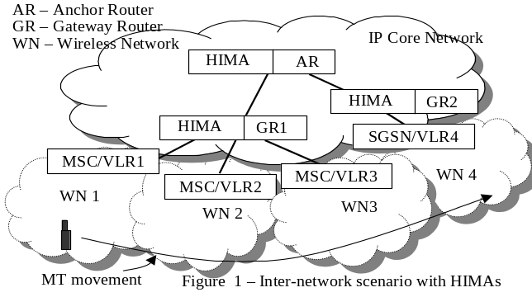
Figure 2 shows the mobility protocols and functions of the framework distributed across the networks. We define a global mobility protocol, which comprises of all components protocols used in the framework. The components of the global mobility protocol are shown along with the local mobility protocols in the wireless networks. The arrows show the interaction and any control and information flow between the component protocols. Using this approach a smooth handoff interaction between layer 3 and layer 2 functions can be achieved. The dotted blocks show the provision for extending the framework to any number of hierarchical levels. Even though the HIMA is suggested to be collocated at some control points in the core network and is supposed to have minimal database processing, the cost overheads of extending the HIMA to more than two hierarchical levels may not be justified under all cases. Hence, the number of levels of hierarchical control using HIMA is at the discretion of the Network and Service provider. Detailed specification of the protocols and their interaction are outside the scope of this article. Some details are available in [11].

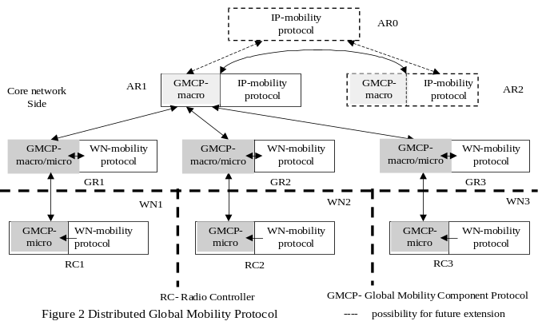
Though HIMAs are available at various control points in the core network, a mobile user can request to be anchored to one HIMA as his primary HIMA. Any HIMA’s below the primary HIMA will act as secondary HIMAs to the MT. This approach optimizes across call set up delays, signaling traffic and database processing. It facilitates handoff for seamless roaming and supports QoS mapping and negotiations as the user moves across different wireless networks. It further avoids the centralized database dependency and associated single-point bottleneck and failures. These are highlighted in the next section.

Features of the HIMA
A number of functions that a HIMA can perform are listed in this section. Not all the functions that are listed below may be present at all HIMAs. The functions present at a HIMA will depend on its hierarchical level and the mobility support requirements of the MTs in its footprint.
Before we discuss the HIMA features, we like to mention the use of the swap scheme proposed in [12] which, will be used at the MSC/VLRs. The swap scheme will simplify and reduce the load and processing at the HIMA and make the framework efficient. Hence, we provide a couple of lines on the swap scheme here. In [12], the authors proposed the use of swap databases at the MSC/VLRs of the participating systems. The MSC/VLRs supporting swap have a primary database for storing data of all currently roaming mobile users in their area. When the mobile user leaves to visit a neighbouring network, the profiles are moved into a secondary storage, with the expectation that the user may roam back. This scheme does not increase the load or delays on the existing databases at the MSC/VLRs; neither does it increase their buffer capacity requirements and the database access times. However, for a returning user, the data can be retrieved quickly from the secondary database with reduced signalling overheads and the associated delays. In the case of seamless handoff for the roaming user, this feature will reduce latency considerably as the user profiles can be retrieved quickly.
Following is a list of all features that may be incorporated in a HIMA.
- The primary HIMA may function as a HLR agent to mobile users registered with it and who are currently in its domain. Hence, it will store all user/service profiles of such mobile users locally. This aids in quick call setup and authentication during inter-network roaming. The quick call set-up is effective only if the calling user is within the footprint of the primary HIMA of the MT.
- The duration for which HIMA acts as a HLR agent to any Mobile user is timed – i.e. it is a cached database, hence if the roaming profile of the user changes the primary HIMA allocated to the MT can change.
- The user / service profiles at the HIMA are used only when required i.e. its use as a HLR agent is limited. This is because the participating MSC/VLRs support a swap database. Hence, when the HIMA is not functioning as a HLR agent, it functions as a pointer to the current MSC/VLR serving the mobile user. This optimises on the amount of signalling traffic.
- The HIMA functions as the anchor point or crossover point for incoming data to the mobile user, to provide call/connection continuity as the user moves from one network to another. This will be very useful especially if the core network is packet switched. (If the core network is not a packet switched network, then the HIMA may act only as a HLR agent and pointer.)
- The HIMA may provide a) translations of inter-network messages and b) QoS mapping and/or negotiations across the wireless networks for inter-system roaming. Location updates/prelim handoff messages will be triggered, when a mobile user enters the boundary cells of his current network, which border another neighbouring network. This happens if the mobile user has a history or service profile for travelling across the networks, and satisfies the prelim-handoff criteria. Such location updates and preliminary handoff messages will be handled via the HIMA.
- In the case of a packet switched core network, on receiving such messages the HIMA will trigger bi-casting and act as an anchor or crossover point. Bi-casting was proposed in [10] to avoid delays in layer 3 handoff, especially in IP networks.

Feasibility Aspects of the Framework

SELECTION OF THE PRIMARY HIMA
A scheme to determine a primary HIMA for an MT is provided in Appendix A. The MT mobility profile that is of interest to us consists of IP addresses of the networks into which the MT roams regularly and from which it receives many calls. This scheme will help the MT select a HIMA at the GR or the AR as its primary HIMA. The functions impose hardly any load on the MT. In general, the mobility profile of an MT does not vary significantly from day to day. When an MT is just starting, the mobility profile may be empty, in which case the procedures for a normal handoff will be initiated.

REGISTRATION AND PRELIM-HANDOFF INITIATION
In wireless networks, the MT monitors the signal strength of the Base Transceiver Station (BTS) or Transceiver System with which it communicates. In the case of cellular systems, the BTS broadcasts the adjacent BTS ids (identifications) and their beacon signal frequencies. The MT tunes in to the adjacent BTS during its idle time slots to monitor the downlink signal strength from the transceivers. This monitored information is used to decide the BTS to which an MT attaches eventually. Hence, it is proposed that such edge BTS or Transceiver Systems be used to broadcast the presence of an adjacent network, which is different from the current one. On hearing this broadcast, and based on its mobility profile, the MT makes the decision to initiate a request for intersystem registration. If the MT has such a profile, has an active call or connection and its criteria for prelim-handoff is satisfied, it then decides to initiate the registration/prelim handoff request message to the HIMA (see Section 3.4). On receiving this message the HIMA gets ready to perform QoS mapping and initiate bi-casting if it is a crossover control to facilitate a smooth and seamless connection / call handoff across the different wireless networks. If no active call or connection exists then, registration will take place after the MT enters the new network as per the normal procedure.

Prelim Handoff and Old Connection Release
- Prelim handoff is initiated if the user has subscribed for the facility
- Prelim handoff is initiated if the user mobility profile shows regular inter-network movement across the concerned networks.
- “Eager to make - Lazy to release” connection principle advocated in [10] is applied to avoid connection loss and toggling during handover.
- The QoS mapping on the new network should be successful. If the new network is not able to support the requested QoS, a minimum QoS (if specified as part of the user’s service profile) may be negotiated. (QoS negotiation and mapping is a study separately undertaken by us and not included here.)

Release criteria
- The resources in the old network will be held until the MT is entirely out-of-range or is explicitly informed by the new network. After the MT makes connection with the new wireless network, the new network then informs the old wireless network to release the resources.

Study of the Framework

Study Scenario1: The MT makes inter-network move while having an active call or connection. In this case, the MT initiates a location registration/prelim handoff request message at the current network before leaving it. The message is initiated if the criteria for prelim handoff as defined in Section 3.4 are satisfied.
Study Sceanrio2: The MT makes inter-network move without an active call. In this case, the MT initiates the normal location registration procedure once it has entered the new network.

Signalling in the Proposed Scheme
The cases to be explored with respect to the two study-scenarios identified above are detailed here. All cases are discussed with reference to inter-network roaming scenario of Figure 1. Cases for location update and preliminary handoff will be discussed first, followed by the cases for call delivery. In this section, the systematic signalling procedure for the HIMA scheme is outlined. The corresponding information flow diagrams for both the HIMA and the BLR scheme are included where necessary.

LOCATION UPDATE AND PRELIM-HANDOFF
Under the two study-scenarios, four cases can be identified for location update and prelim handoff signalling. They are given in Table 1.

Case 1 – HIMA (refer Figure 3)
- MT sends an inter-system location registration / prelim handoff request message via the Base Station Controller (BSC) or Transceiver Controller and its current MSC/VLR1, when it is in the edge cell of the current network. (BSC is not shown in the figure)
- MSC/VLR1 has the user /service profile and will check the validity for intersystem roaming of the MT, before it forwards the inter-system location-registration/prelim handoff request message to the HIMA at GR1.

Table 1: Location Update and Prelim Handoff request cases for the HIMA scheme
Case1 | MT has an active call and roams across Wireless Network (WN) 1 to WN2 in Figure 1. The MT has its primary HIMA at GR1.
Case 2 | The MT does not have an active call, and roams across WN1 to WN2 and has its primary HIMA at GR1.
Case3 | MT has an active call and roams across WN2, WN3 and WN4. The primary HIMA is at AR and secondary HIMAs at the GR1 and GR2.
Case 4 | The MT does not have an active call and roams from WN2 to WN3 to WN4. The primary HIMA is at AR and secondary HIMAs at GR1 and GR2.

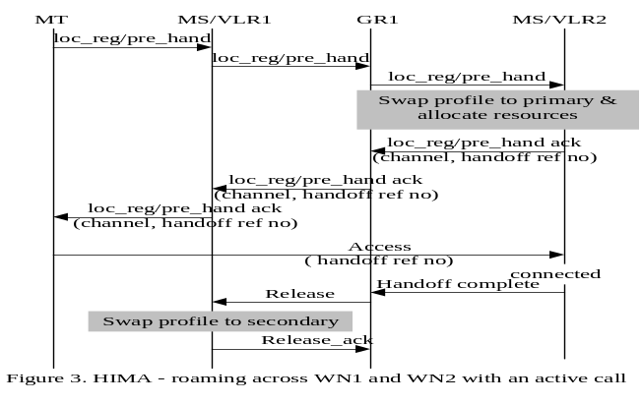
- The HIMA at GR1 forwards the location registration /prelim handoff request to the new MSC/VLR2. There are two cases to consider.

Case a: First-Time Entry of MT
  - The HIMA will forward the user /service profile along with the location registration/prelim handoff message.
  - The MSC /VLR2 will store the information in its primary database.

Case b: Subsequent Entries of MT – this is the case shown in Figure 3
  - The HIMA only sends the location registration/prelim handoff request message.
  - MSC/VLR2 will swap the mobile users/service profile from the secondary database into the main database
- MSC/VLR2 then makes resource allocation for the new incoming call and sends the details of the reservation and a handoff reference via a location registration/prelim handoff acknowledgement message to GR1.
- GR1 will forward the acknowledgement message and reservation details with handover reference number to the MT via MSC/VLR1 and the corresponding BSC.

Release phase
- When the MT is in the new network, it sends an “Access” message to the new network, on the specified channel and with the handover reference number.
- After a successful layer 2 connection setup of the MT at the new network, MSC/VLR2 receives this message
- The MSC/VLR2 then sends a ‘handoff complete’ message to GR1
- GR1 forwards a ‘release’ message to MSC/VLR1 and will set its pointer for the MT to the new MSC/VLR2
- MSC/VLR1 on receiving the ‘release’ message swaps the mobile user/service profile into the secondary database for future use. If WN1 is the Home Network of the MT, then no swap will occur at MSC/VLR1.

Case 1 –BLR scheme
According to the studies in [2], the BLR and BIU are connected to the MSCs/VLRs of the two networks and provide message transformation. BIU is to handle compatibility of air-interface and authentication of mobile users. However, case 1 cannot be discussed for the BLR scheme, as the mechanisms and messages for handoff are not available.

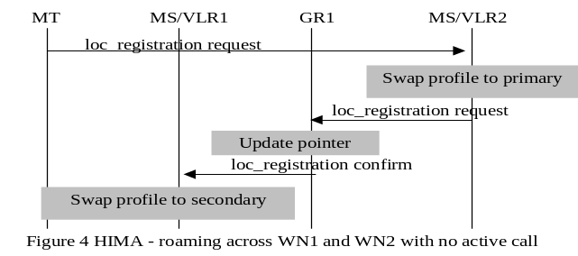

Case 2 –HIMA scheme (refer Figure 4)
- The MT waits till it is in the new MSC/VLR2, it then sends a location-registration request to MSC/VLR2

Case a: First-Time Entry of the MT
  - The MSC/VLR2 sends this location registration request to the HIMA at GR1
  - The HIMA acts as a proxy HLR and downloads all the user/service profile and provides authentication for the user
Case b: Subsequent Entries of the MT- this is the case shown in Figure 4
  - The MSC/VLR2 swaps the user/service profile from the secondary database to the primary database.
- The MSC/VLR2 sends a location registration acknowledgement to the GR1
- GR1 sends a ‘release’ message to MSC/VLR1 and updates its pointer for the MT
- MSC/VLR1 will then move the data of the mobile user from its primary to the secondary database. If WN1 is the Home Network of the MT, then no swap will occur at MSC/VLR1.
Case 2 – BLR scheme (Remote Home Network)
Figure 5 shows the information flow when the called MT’s home network is remote. Though this case is not analyzed in [2], we have extrapolated from the signaling provided for the case where one network is a home network.
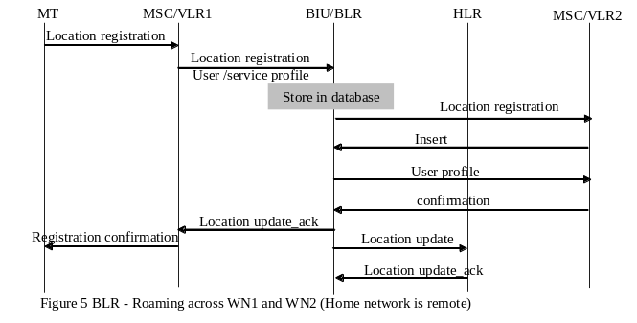
Case 2 – BLR scheme (Local Home Network)
Figure 6 has been reproduced from [2] for easy reference. WN1 is the home network.
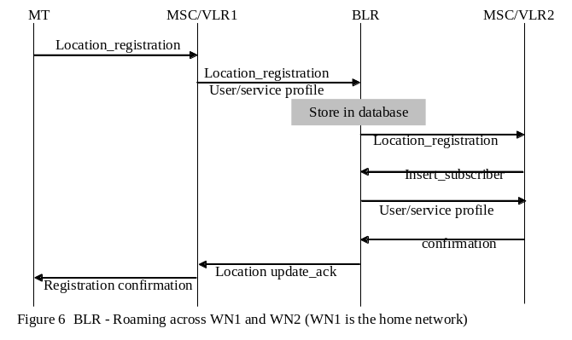

Case 3 – HIMA scheme (refer Figure 7)
When the MT moves from WN2 to WN3 the signals exchanged for location update follow a similar procedure as outlined in Case 1, though the signals flow via the AR for the first entry case as the AR is the proxy HLR. When the user moves from WN3 to WN4, the following procedure takes place
- MT sends an inter-system location registration /prelim handoff request message via the BSC and its current MSC/VLR3, when it is in the edge cell
- The MSC/VLR3 has the user/ service profile and it checks the MT’s validity for intersystem roaming, before it forwards the inter-system location registration / prelim handoff request message to the HIMA at GR1
- The HIMA at GR1 recognizes the request as a request for an inter-network movement involving the AR, and will forward the message to AR

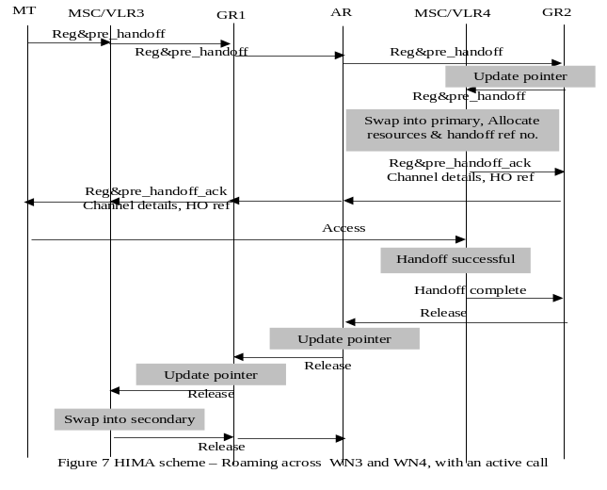
- The AR will perform one of the following

Case a: First-Time Entry of the MT
a. The AR forwards the user/service profile along with the location registration/prelim handoff message to the new MSC/VLR4, via GR2.

Case b: Subsequent Entries of the MT– this is the case shown in Figure 7
  - The AR forwards the registration/prelim handoff request message via GR2 to the new MSC/VLR4.
  - The MSC/VLR4 retrieves the MT user / service profile from the secondary database.
  - GR2 sets MT pointer to the new MSC/VLR4.
- MSC/VLR4 allocates resources for the new incoming connection and sends its registration /handoff acknowledgement to the AR with the new resource allocation details and handover reference number via GR2.
- The AR forwards the acknowledgement and allocation details to the old MSC/VLR3, via GR1.
- The old MSC/VLR3 will forward this information to the MT.

Release phase
Same as in case 1, but the release messages flow via AR.

Case 3- BLR Scheme
This case cannot be discussed for the BLR scheme, for the same reasons given in case 1.

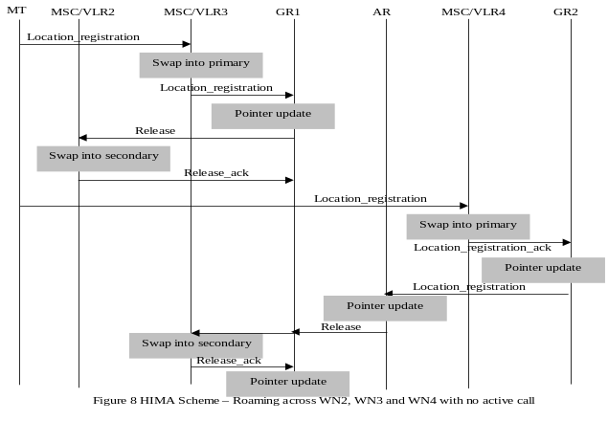

Case 4- HIMA scheme (refer Figure 8)
The signaling for roaming from WN2 to WN3 is the same as before and not repeated. The signaling required for roaming between WN3 to WN4 is given below.
- The MT waits until it has entered the new MSC/VLR4. It then sends a registration request to the new MSC/VLR4.

Case a: First-Time Entry of the MT
  - MSC/VLR4 forwards the location update to the HIMA at GR2.
  - The HIMA at GR2 will forward the location update to the AR.
  - The AR will provide user/service profile via GR2 to MSC/VLR4.

Case b: Subsequent Entries of the MT- this is the case shown in Figure 8
- MSC/VLR4 has the user /service profile in its secondary database, which it will swap to the primary database.
- MSC/VLR4 sends an acknowledgement to GR2. GR2 updates the pointer to the new location of MT and forwards the acknowledgement message to the AR.
- AR notes the current VLR of the MT updates its pointer and sends a location update acknowledgment to GR1.
- GR1 will forward the message to the old MSC/VLR3.
- The old MSC/VLR3 will move the user and service profile to its secondary database and send a “release_ack” message.
- GR1 will now update its MT pointer to point to the AR.

Case 4 – BLR scheme
While moving from WN2 to WN3, the information flow will be the same as for Case2 i.e. the ‘local home network’ case. While moving from WN3 to WN4 the information flow will be repeated. When the home network is remote, information flow while moving from WN2 to WN3 follows case 2, which is the ‘remote home network’ case, and for movement from WN3 to WN4 the information flow will be the repeated.

CALL DELIVERY
Information flows for call delivery when called and calling MT are in the home network of the called MT is not discussed, as it is a trivial case. The studies here are restricted to two cases, where the called and calling MT are within the footprint of the AR. For calls arriving from networks not within the footprint of the AR or GR, the normal procedure is used.

Table 2: Cases of study in Call Delivery
Case 1 | Intra-GR call, where the calling MT is in WN2 and the called MT is in WN3 i.e. under one GR
Case 2 | Intra-AR call delivery, for example the calling MT is in WN2 and called MT is in WN4, i.e. they are under one AR domain. The primary HIMA for the called MT is at AR

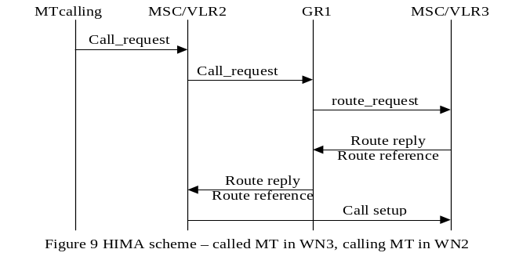

Case 1- HIMA scheme (refer Figure 9)
The information flow is not affected if WN2 is the home network or not.
- The calling MT initiates a call by sending a call request message to MSC/VLR2.
- The MSC/VLR2 will forward the call to the GR1.
- The HIMA at GR1 has the details of the called MT and its current MSC/VLR3.
- The HIMA at GR1 then sends a route request message to the MSC/VLR3.
- The MSC/VLR3 responds with the request acknowledge and a routing reference number.
- The HIMA at GR1 forwards the routing reference number to the MSC/VLR2.
- MSC/VLR2 now initiates a call setup procedure to the MSC/VLR3.

Case 1 – BLR scheme
The information flow is as shown in Fig. 10 and has been reproduced from [2] for convenience. The home network may be local or remote.
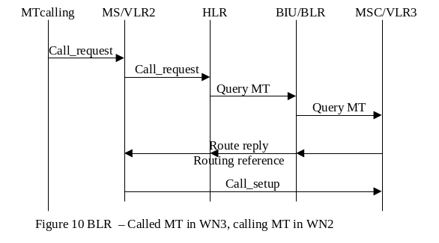
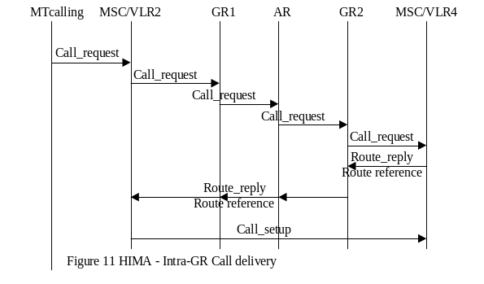

Case 2- HIMA scheme (refer Figure 11)
This case covers non-adjacent networks for where calling MT is at WN2 and called MT is in WN4. The information flow is not affected whether one of the networks is a home network or not.

- The calling MT sends the call request message to MSC/VLR2.
- The MSC/VLR2 forwards the message to the HIMA at GR1.
- The HIMA at GR1 forwards the message to AR, which has a pointer to the current MSC/VLR4 of the called MT.
- The HIMA at AR will then forward the message to the called MSC/VLR4 via GR2.
- The MSC/VLR4 will acknowledge the route request with a routing reference number to the AR via the GR2.
- The AR then forwards the routing reference number to the calling MSC/VLR2.
- The MSC/VLR2 will initiate call setup procedures with the called MSC/VLR4.

Case 2- BLR scheme
This case was not considered for the BLR scheme, as the signaling would be highly complex.

Cost Calculations

Parameters for Location Update Cost Analysis
Some of the cost parameters used in estimating costs for location update and call delivery are given below. Of these cost parameters, some have been introduced to reflect the cost calculations necessary for the BLR scheme. All transmission cost components have been lumped into two parameters c₁ and c₂ to ease in calculations. Boundary LAs and associated costs for movement into and out of the boundary LAs, were used for cost estimates in [2]. Such costs are provided here only for the BLR scheme. The HIMA scheme incurs costs only for inter-network movements (or for predicted inter-network movements).

c₁ = transmission cost of messages between VLR and BLR, between HLR and BLR, when HLR is local or in the adjacent network (BLR scheme) = transmission cost of messages between VLR and GR, and between GR and AR (HIMA scheme)
c₂ = transmission cost of message between HLR and VLR, or between HLR and BLR, when the HLR is remote
p₀ = probability that an MT roams from a boundary LA to a non-boundary LA (BLR scheme)
p₁ = probability that an MT roams from a boundary LA to another boundary LA (BLR scheme)
p₂ = probability that an MT roams from a boundary LA in one system to a boundary LA in another system (BLR scheme) = probability that an MT makes an inter-network movement (HIMA scheme)
p₃ = probability that an MT roams from a non-boundary LA to a boundary LA (BLR scheme)
α = weight factor for transmission cost
β = weight factor for access cost of databases
η = weight factor on transmission costs to carry user/service profile in messages
q = probability of a roaming user having an active call
γ = probability that either the current network or an adjacent network is the home network
a = database access and processing cost, a_{v} will be processing costs at the VLR, a_{h} – processing costs at the HLR and a_{b}- processing costs at the BLR
s_{v}= swap costs in databases (in this case it is the VLR) implementing the swap technique
d_{l} = database look-up cost at the HIMA
p_{u} = pointer update cost at a database
C_{lu_blr} (x-yn)- location update cost for BLR scheme, where x is the contributing component, y is the number of networks involved, i.e., y =2 for a 2-network scenario and y= 3 for a 3-network scenario
C_{lu_hima} (x-yn)- location update / prelim handoff cost for HIMA scheme, where x is the contributing component for a y- network scenario
TC_{lu_blr} (yn)- total location update cost for BLR scheme for a y- network scenario
TC_{lu_hima} (yn)- total location update / prelim handoff cost for HIMA scheme for a y- network scenario

Location Update Cost Calculations
The cases considered here take into account all the relevant cases identified under Section 4.1.1. The first two equations under each sub-case provide calculations for the 2-network scenario, when the mobile user moves from WN1 to WN2. Cases 1 and 2 (Section 4.1.1) for the HIMA scheme and case 2 only (Section 4.1.1) for the BLR scheme are accommodated. Similarly, the next two equations in each sub-case cover all calculations for the 3-network scenario, when the mobile user roams from WN2 to WN3 to WN4. Cases 3 & 4 (Section 4.1.1) for the HIMA scheme and case 4 only for the BLR scheme are considered. A number of sub-cases below distinguish between movements within and across boundary and non-boundary LAs and are required for signalling in the BLR scheme.

Sub-case 1: User roams from a boundary LA to a non-boundary LA in a network In the costs represented here there will be slight variation compared to that provided in [2] as we have assumed that in a network there is only one MSC/VLR. However, the first component in equation 1 (given within the curly braces) is incurred, as the information in the MSC/VLR2 of the adjacent network has to be cleared, though the BLR is a cached database. The second cost component, we have extrapolated from the given scheme to accommodate for the case when a user is roaming across networks, which are not his home network and messages are to be sent to the remote HLR to update it. The cost component c₂ accommodates this.
In the 3-network scenario, the costs estimates will have two main components, one component is incurred while moving from WN2 to WN3 and the other is incurred while moving from WN3 to WN4. These are provided separately. As WN2 is considered the home network of the called MT, roaming across WN3 to WN4 will be handled as a “remote home network” case. For the cost estimates in C_{lu_blr} (1-3n), the first two components (each cost set within the curly braces is a cost component) are the same as for the 2-network scenario and the third component is for roaming from WN3 to WN4. The above comments are applicable to all subsequent sub-cases.

C_{lu_blr} (1-2n) = γ {4αc₁+ β(a_{h}+ a_{v})} + (1- γ) {4αc₁ + 2αc₂+ β(a_{h}+ a_{v})} (5.1)
C_{lu_hima} (1-2n) = 0
C_{lu_blr} (1-3n) = γ{4αc₁ + β( a_{v+} a_{h})}+ (1- γ) {4αc₁ + 2αc₂+ β(a_{h}+ a_{v+} a_{b})} + {4αc₁ + 2αc₂+ β(a_{h}+ a_{v+} a_{b})} (5.2)
C_{lu_hima} (1-3n) = 0

Sub-case 2: User roams from boundary LA to another boundary LA in the same network. According to the BLR scheme, the HLR has to be updated on the latest boundary LA change. This has been accommodated in the equations.

C_{lu_blr} (2- 2n) = γ{4αc₁ + β(a_{b}+ a_{v+} a_{h})} + (1- γ) {4αc₁ + 2αc₂+ β(a_{h}+ a_{v+} a_{b})} (5.3)
C_{lu_hima} (2- 2n) = 0
C_{lu_blr} (2- 3n)= γ{4αc₁ + β(a_{b}+ a_{v+} a_{h})} + (1- γ) {4αc₁ + 2αc₂+ β(a_{h}+ a_{v+} a_{b})} + {4αc₁ + 2αc₂+ β(a_{h}+ a_{v+} a_{b})} (5.4)
C_{lu_hima} (2- 3n) = 0

Sub-Case 3: User roams from a boundary LA in one network to a boundary LA in another network. For the HIMA scheme, the first cost component is incurred when a mobile user does not have an active call, the second cost component is incurred when the mobile user has an active call. Whether the home network is remote or local will not affect the costs for the HIMA scheme.

C_{lu_blr}(3-2n) = γ{4αc₁+ β(a_{b}+ a_{v}+ a_{h} ) } + (1-γ) {4αc₁+ β(a_{b}+ a_{v}+ a_{h})+ 2αc₂} (5.5)
C_{lu_hima}(3-2n) = (1-q) {2α c₁ +β(P_{u}+ s_{v})} + q {4α(1+ϕ) c₁ + 3α c₁+ 2βs_{v}} (5.6)
C_{lu_blr}(3-3n) = γ{4αc₁+ β(a_{b}+ a_{v}+ a_{h}) } + (1-γ) {4αc₁+ β(a_{b}+ a_{v}+ a_{h})+ 2αc₂} + {4αc₁+ β(a_{b}+ a_{v}+ a_{h})+ 2αc₂} (5.7)
C_{lu_hima}(3-3n) = (1-q) [2{2α c₁ +β( p_{u}+2s_{v})} + q {8α(1+ϕ) c₁ +6 c₁+ 2β( p_{u}+2s_{v})}] (5.8)

Sub-Case 4: User roams form a non-boundary LA to a boundary LA This case was not evaluated in [2], because for the comparative study there, which involved the BLR scheme and the GLR [1] scheme, it was not essential. In the current comparative study, however this component is essential and hence has been estimated. In the equations for the BLR scheme, messages are shown weighted with η, because they carry the user / service profiles and will incur higher costs.

C_{lu_blr}(4-2n) = {2αc₁+ 2αηc₁ +β(a_{b}+ a_{v}+ a_{h} ) } γ + (1-γ) {4αc₁+ β(a_{b}+ a_{v}+ a_{h})+ 2αηc₂}, (5.9)
C_{lu_hima}(4-2n) = 0
C_{lu_blr}(4-3n) = {4αc₂+ 2αηc₂ +β(a_{b}+ a_{v}+ a_{h} ) } γ + (1-γ) {4αc₂+ β(a_{b}+ a_{v}+ a_{h})+ 2αηc₄} + {4αc₂+ β(a_{b}+ a_{v}+ a_{h})+ 2αηc₄} (5.10)
C_{lu_hima}(4-3n) = 0

Total weighted costs
TC_{lu_blr}(2n)= p₀C_{lu_blr} (1-2n) + p₁C_{lu_blr} (2-2n) + p₂C_{lu_blr} (3-2n) + p₃C_{lu_blr} (4-2n) (5.11)
TC_{lu_hima}(2n)= p₂C_{lu_hima} (3-2n) (5.12)
TC_{lu_blr}(3n)= p₀C_{lu_blr} (1-3n) + p₁C_{lu_blr} (2-3n) + p₂C_{lu_blr} (3-3n) + p₃C_{lu_blr} (4-3n) (5.13)
TC_{lu_hima}(3n)= p₂C_{lu_hima} (3-3n) (5.14)

Parameters- Call Delivery Cost Analysis
λ₁ = call arrival rate from WN2, (WN2 could be the home network in some cases)
λ₂ = call arrival from WN3
p₄ = probability of a call from anywhere within the footprint of the AR except the home network and its adjacent network. This parameter will be used for cost assessment in the HIMA scheme only
C_{cd_blr}(x) = Call delivery costs for the BLR scheme, where x is the cost component
C_{cd_hima}(x) = Call delivery costs for the HIMA scheme, where x is the cost component
TC_{cd_blr} = Total Call delivery costs for the BLR scheme
TC_{cd_hima} = Total Call delivery costs for the HIMA scheme
Two main cases are considered. Case 2 involves call arrivals within the footprint of an AR, where the called MT is registered with the HIMA. Case 1, involves call arrivals from an adjacent network and addresses the situation where only two adjacent networks, e.g. WN2 and WN3 are involved and is inline with Case 1 of Section 4.1.2. This would fall under the category of intra-GR call delivery in the HIMA scheme. However, the following sub-cases were considered under Case 1 to facilitate cost comparison with the BLR scheme.

Table 3: Subcases for Call Delivery study
Subcase 1 | calling MT and called MT in WN2 | Cost components include  - Home network is local with probability γ  - Home network is remote with probability 1-γ  - Called MT is in the boundary LA  - Called MT is in a normal LA
Subcase 2 | calling MT in WN2, called MT in WN3 | Same cost components as above
Subcase 3 | calling MT and called MT are in WN3 | Same cost components as above

Under each subcase the cost components mentioned in the 3rd column will be considered. When WN2 is the home network, the probability that the called MT is in the home network is given by (1-p₂); where p₂ is the probability that an MT makes an inter-network move and is not in the home network. When the MT is not in the home network, the home network could be adjacent or remote. The home network is adjacent with a probability of γ and is remote with a probability of (1-γ). For the BLR scheme if the called MT is in the boundary LA it would incur a different cost as compared to when it is in a normal LA [2]. 1-p0-p2 gives the probability that the called MT is in a boundary LA within a network, because p₀ is the probability that the MT continues to be in a non- boundary LA in a network.
Case 2 considers the situation where the call delivery is between networks under the footprint of an AR. This case will be evaluated only for the HIMA scheme. No specific call arrival pattern or rates are assumed here. The calculations are done for all calls arising within the footprint of the AR, where the call delivery has to take place via HIMA in the AR. The BLR scheme was developed for scenarios involving adjacent networks and estimating the costs under Case 2 for the BLR scheme would not be appropriate.
The call delivery cost estimates under each of the case and their sub-cases are provided below.

Case 1: Intra-GR Call Delivery (Adjacent Networks)
Sub- Case 1:
This is the case where the called and calling MT are in the same wireless network and this network is the home network of the called MT. Probability that the called MT is in the home network is given by (1-p₂). A cost is incurred for the BLR scheme if the MT is in the boundary LA, where the probability that the MT is in boundary LA is given by (1-p₀-p₂), because po is the probability that the called MT is in a non-boundary LA.
C_{cd_blr}(1)= (1-p₂) λ₁ [po β(a_{h}) + (1-p₀-p₂) {2αc₁ + β(a_{h}+a_{v})}]/ ( λ₁ + λ₂) (5.15)
C_{cd_hima}(1)= (1-p₂) λ₁po β(a_{h})/ ( λ₁ + λ₂) (5.16)

Sub-Case 2:
This is the case where the called MT is not in its home network i.e. it is roaming; hence, the home network may be adjacent or remote. Depending on whether the MT is in a boundary LA or not the costs for the BLR scheme would be different and these two components are shown in the equation below.
C_{cd_blr}(2) = p₂ λ₁ [{6α( c₁ ) + β(a_{h}+ a_{v} + a_{b} )} γ + (1-γ){α(4 c₂+4 c₁ ) + β(a_{h}+ a_{v} + a_{b} )} ]/( λ₁ + λ₂) (5.17)
C_{cd_hima}(2) = p₂ λ₁ [{6α c₁ + β(d_{l} + a_{v} )}]/( λ₁ + λ₂) (5.18)

Sub-Case 3:
This is the case where the called MT and calling MT are in the same network, but this is not the home network of the called MT. The home network in this case can be adjacent or remote.
The authors of [2] have assumed that the queries to locate the called MT will be addressed to the BLR. This can happen only if the calling MT and called MT are in the boundary LA of the same network and locality of reference is used at the BLR. However, the calling MT has no way of knowing that the called MT is in the boundary LA of the same network, so it is appropriate that the query be directed to the MSC/VLR and be forwarded from there on, otherwise after a failure with a query to the BLR, the MSC/VLR will have to be contacted. However, in equation 5.19 we have provided the costs assuming locality reference at the BLR. This has two cost components; one, when the MT is in the boundary LA and the other when the MT not in the boundary LA.
C_{cd_blr}(3)= p₂ λ₂ [(1-p0-p2) γ{α(2c₁ ) + β( a_{b} + a_{v})}+ γ p0{2α c₁ + β( a_{v} + a_{h} ) } + (1-γ){ ( 2α c₂ + 2α c₁ + β( a_{v} + a_{h}+ a_{b} ) } ]/( λ₁ + λ₂) (5.19)
C_{cd_hima}(3) = p₂ λ₂ [{2α c₁ + β d_{l} }]/( λ₁ + λ₂) (5.20)
Total Call Delivery Costs
TC_{cd_hima} = C_{cd_hima}(1) + C_{cd_hima}(2) + C_{cd_hima}(3) (5.21)
TC_{cd_blr} = C_{cd_blr}(1) + C_{cd_blr}(2) + C_{cd_blr}(3) (5.22)
Case 2: Inter-GR Call Delivery
In this case, the calling MT is in WN2 and called MT is in WN4. For analysis, we have given different values to p₄, to provide a distribution of the costs incurred.
C_{cd_hima}(4) = p₄ [{12α c₁ + 3β( d_{l}+ a_{v} )}] (5.23)

Values of Parameters for Cost Analysis

Table 4: Values used for cost parameters
Database access, swap and lookup cost
a_{h} | a_{v} | a_{b} | d_{l} | s_{v} | p_{u}
8 | 5 | 5 | 2 | 3 | 2
Signaling transmission costs
c₁ | c₂ | ϕ | η
1 | 4 | 1.1 | 1.1
For all calculations it is assumed that p₀=p₁=p₃= (1-p₂)/2, where p₂ is the inter-network roaming probability. Other values can be used in the equation to conduct an extended study.

Cost Comparisons

LOCATION UPDATE COSTS – 2 NETWORK SCENARIO
Graph 1 is the plot of location update costs versus the inter-network roaming probability for the BLR and the HIMA schemes. For a value of γ (gamma)= 0.2, the weights on the database and transmission costs i.e. β (beta) and α (alpha) respectively were varied from 0.2, 0.5 to 0.8. As the weight on the database costs increases, the location update costs are seen to be increasing, which is as expected. However, for the BLR scheme
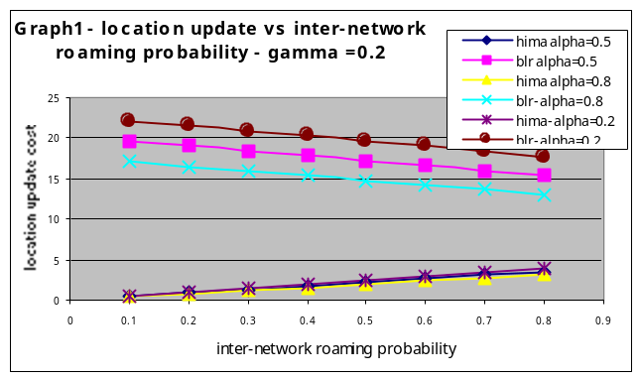
one can notice that as the inter-network roaming probability p₂ increases, location update costs are slightly drooping. This is due to the fact that even when there is no inter-network roaming the scheme encounters a “housekeeping” cost as the user moves in the boundary LAs and from the boundary LA to the non-boundary LAs of the same network. Another contributing factor for this behavior is the dependency we have assumed between p₀, p₁, p₃ and p₂. As p₂ increases the others, reduce, thereby reducing the location update costs in the BLR scheme. The graphs for the HIMA scheme, shows an increase with an increase in the inter-network roaming probability. This is because in this scheme cost is incurred only when the user is actually making the move from one wireless network to another. Any preliminary handoff procedures are invoked only if the MT has an active call while making the move. In the BLR scheme, the system is prepared for an eventual move by the MT to the adjacent network as soon as it enters the boundary LA, where as the HIMA scheme gets prepared only when the MT is in the boundary BTS. We feel that getting prepared while in the adjacent BTS should provide sufficient time for initiating seamless hand-over functions.
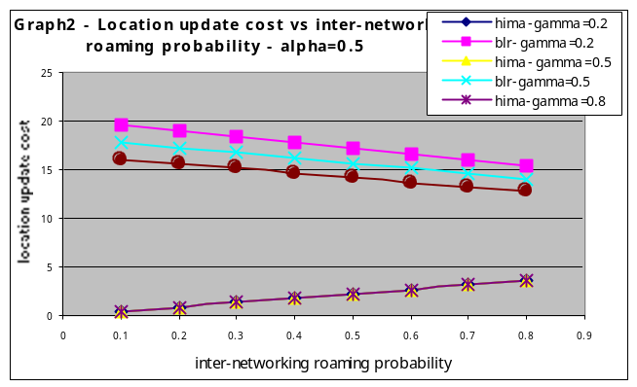 Graph 2, is a plot showing the variation of the location update cost as a function of inter-network roaming probability p₂, for different values of γ, fixed values of α=β= 0.5. When γ is low, it means that there is high probability that the home network of the MT is remote, hence the location update costs will be high. Hence, as γ increases the location update costs for the BLR scheme reduces, as the scheme is efficient when the user has a local home network and is moving across networks, which are adjacent to the home network. Varying γ has no effect on the HIMA scheme, as the HIMA acts as proxy HLR if required
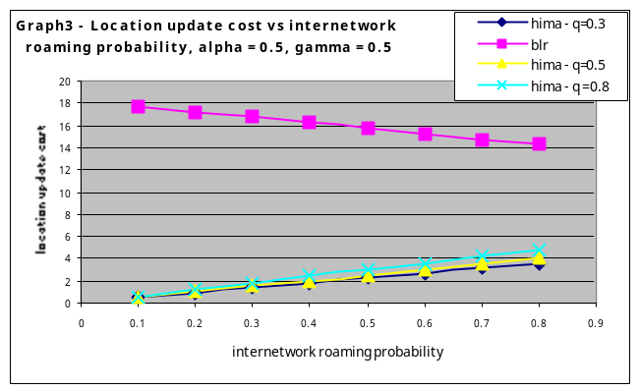 Graph 3 is a plot to show the incremental costs incurred in the HIMA scheme, when more users with active calls move across the networks. As expected, with more users crossing the networks with an active call, the location update costs increase, as more signaling is necessary. The BLR plot has been included but will show no variations, as the cost for an active call was not included in its cost calculations.
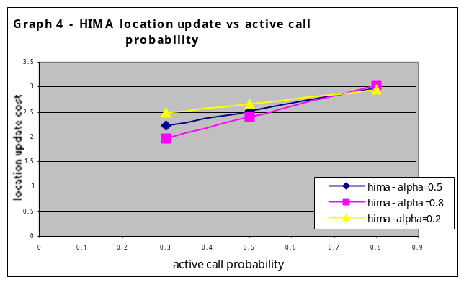
Graph 4 shows an interesting occurrence in the HIMA location update cost, especially in its dependency on the transmission costs, especially when there are more users with active calls crossing the networks,. At the higher end of the graph when there is high active calls probability (i.e. q is high) the location update cost is higher when more weight is given to transmission costs, i.e. α = 0.8. This is because there is comparatively heavy transmission occurring (as compared to database processing) for all the users with the active calls. If the transmission component is weighted in comparison to database costs on an 8 to 2 ratio, the location update costs is higher.

LOCATION UPDATE COSTS - 3 NETWORKS SCENARIO

While Graphs 1, 2 3 and 4 gave the location update costs comparison for a 2-network scenario, Graphs 5, 6, 7 and 8 show similar comparisons for the 3-network scenario. The location update costs can be seen to be nearly double for the 3-network scenarios as compared to the 2 network scenarios. For the BLR scheme, this is reasonable to expect as the procedures and signalling used while crossing WN2 to WN3 will be repeated again while crossing from WN3 to WN4. For the HIMA scheme the scenario used increased the hierarchical control level from 1 to 2 and hence the cost doubles. If all the three networks were under the footprint of a GR, the costs would be less.

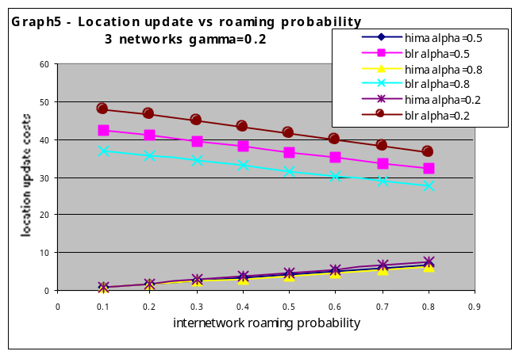

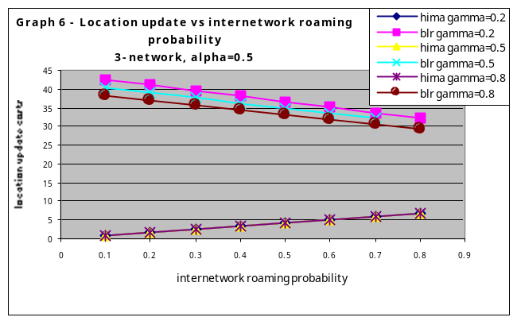

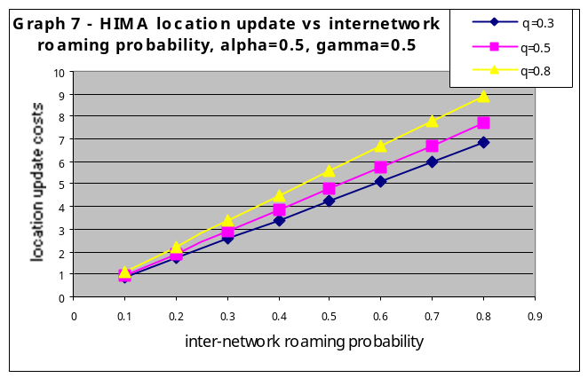
Comparing Graphs 4 and 8, the crossover probability point in Graph 4 was at q=0.7, whereas for the 3- network case the cross over is at q ≈0.56. This is because in a 3-network scenario, the transmissions are almost double that required in the 2-network scenario. Hence, with a lower value of the active call probability (i.e. q =0.56) the location update costs (weighted heavily on the transmissions) is higher than the costs weighted heavily on database access and processing.

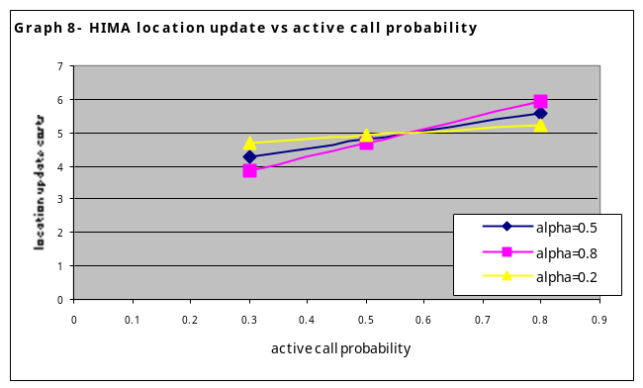

CALL DELIVERY COSTS
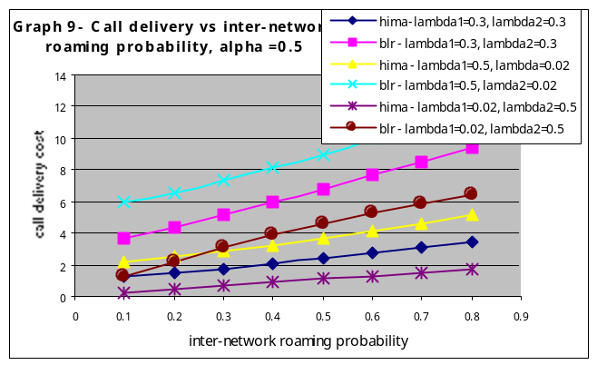 Graph 9 is a plot of the intra-GR call-delivery cost versus inter-network roaming probability of the MT. The plot is for α=β= 0.5. With a higher roaming profile the costs of call delivery increase as expected in all cases, as the roaming MT has to be located before the call can be delivered. The call arrival rates from the 2 networks for both the schemes was varied as shown. When the call arrivals in WN2 are high, (λ₁, i.e. lambda1 is 0.5) the call delivery cost is high. There are 3 cost components: 1) the calling MT and the called MT are in WN2 2) the calling MT is in WN2 and the called MT is in WN3 3) the called MT and calling MT are both in WN3. Two of the cost components are taken into account when the call arrivals are from WN2; hence, the total delivery costs show an increase with higher λ₁. Also not that the call delivery in the case of the BLR scheme increases with increase in roaming probability whereas in Graphs 1 and 2 it was noticed that the location update cost decreases with increasing roaming probability. Hence if the locations update costs and call delivery costs for a particular case of the BLR scheme were summed up, we would obtain a graph for the total location management costs – which would be quite stable with the roaming probability as predicted from the graphs in the original works of [2].
Graph 10 (equations 5.21 and 5.23) provides an inter-GR and intra-GR cost comparison for the HIMA scheme only. The slope for case 2 i.e. an inter-GR roaming case is higher, showing that there is faster increase in call delivery costs. For call delivery in the inter-GR case, the MT has to be located and then the call set-up executed. Hence, if the probabilities of the MT roaming across the three networks increases, two costs are increasing, the locating costs and the call-setup costs and the slope of this graph is steeper.
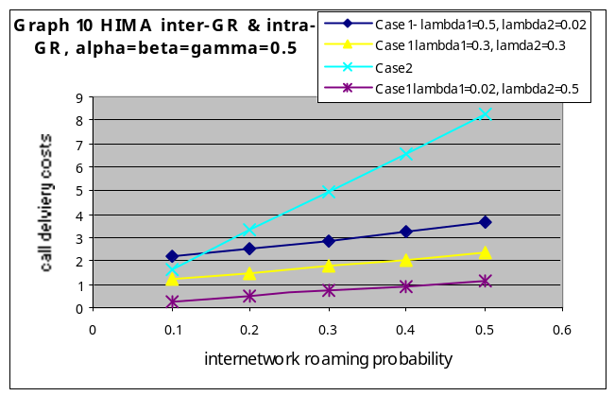
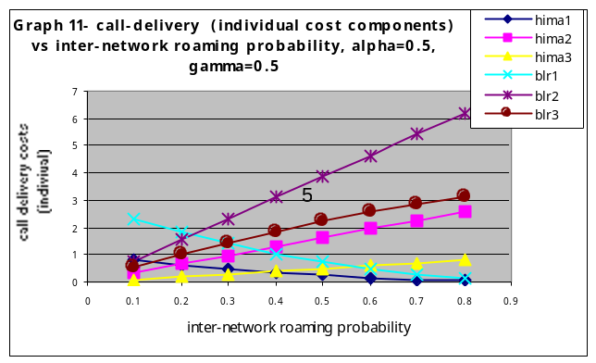
Graph 11 shows plots of the three individual cost components, which make up the total call-delivery costs. λ₁ and λ₂ were set to be of equal value i.e. 0.5. In the case of the BLR scheme the first component incurs less cost if the user’s roaming probability is high - as this cost component is predominantly the cost incurred when the user is at home and is proportional to 1-p₂. Hence, if there is higher probability that the user is not at his home network, the costs will reduce. As compared to the first component, the second and third components will increase with the roaming probability, as they are cost components calculated when the user is roaming away from his home network. A similar pattern can be noticed for the HIMA scheme also. The second cost component incurs the highest cost (most of the time) because this is the case where the called and calling MTs are in different networks. The third cost component is incurred when the called and calling MT are in the same network, which is not the home network. For both sets of graphs belonging to either scheme, it can be noticed that below a certain value of the roaming probability, cost component 1 predominates, and after this value is crossed, cost components 2 and 3 predominate. For example:- in the case of the plots for the HIMA scheme, when p₂ < 0.4, the 1st cost component predominates, whereas, when p₂ > 0.4 the 3rd component predominates. This is because, the 1st cost component is incurred when the calling and called MT are both in the same network which, is also the home network of the called MT. Hence, if the called MT is not roaming much (i.e. p₂ is low) it can be found with a higher probability in its home network and the cost is high.

Latency Calculations

Delay Parameters

Γ = Processing time at the databases
μ = average service time at the database
η = arrival rate of jobs at the database
σ = variance of processing time at the database
ϖ = waiting time before service at the databases
c₁ = transmission delay for local or adjacent home networks
c₂ = transmission delay for remote home networks
ξ = delay weight factor for transmitting user/service profile in messages
ϕ = delay weight factor to carry prelim-handoff messages
δ_{s} = swap delays at the VLR
δ_{l} = lookup delays at the GR, AR
δ_{up} = pointer update delays at the GR, AR
D_{lu_blr}(x) = delay due to location registration in the BLR scheme, where x is the contributing factor
D_{lu_hima}(x) = delay due to location registration /prelim handoff in the HIMA scheme, where x is the contributing factor
TD_{lu_blr} = Total delay due to location registration in the BLR scheme
TD_{lu_hima} = Total delay due to location registration /prelim handoff in the HIMA scheme

D_{cd_blr}(x) = call delivery delay in the BLR scheme, where x is the delay contributing component
D_{cd_hima}(x) = call delivery delay in the HIMA scheme, where x is the delay contributing component

TD_{cd_blr} = Total call delivery delay in the BLR scheme
TD_{cd_hima} = Total call delivery delay in the HIMA scheme

Location Registration Delays
In the location registration process the end-to-end response time is to be calculated from the time the MT initiates a registration request till a confirmation of registration is received at the MT. The delay comprises of delays due to transmission of signals and database access and database processing delays. When the home network is local or an adjacent network the transmission delays are low. If the home network is remote, the transmission delays will be high. For the case where the database access requires retrieving the MT profiles an extra delay factor has been included in the processing times at the databases.
The processing model for all databases can be assumed an M/G/1 queue [2], where the service time is considered a general distribution and the arrival of jobs Markovian. The total delay for a single registration process comprises of the system time for all the databases that are involved in the processing plus any transmission delays. The system time in the database in turn comprises the database processing time (or service time) plus the waiting time in the queues. The waiting time in turn depends on the arrival rate of jobs at the database.
For the M/G/1 queue system, using the delay parameters mentioned in section 7.1, the system time for any database can be obtained using the following equation.
Γ = 1/μ + ϖ (6.1)
Where ϖ can be obtained using the Pollaczek-Khinchin equation as given below

ϖ =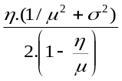 (6.2)
The only cases considered for estimation of delays are the sub-cases 1, 2 and 3 of Section 6.2 pertaining to the 2-network scenario. Though sub-case 4 of the BLR scheme incurs delay in inter-system registration, they are not provided and are not included in the graphs and comparisons that follow. In the HIMA scheme delays for prelim handoff for active calls are included.
D_{lu_blr}(1) = {4c₁+ Γ_{v} + Γ_{h}} +(1-γ){2c₂} (6.3)

D_{lu_blr}(2) = {4c₁+ Γ_{v} + Γ_{h}+ Γ_{b} } +(1-γ){2c₂} (6.4)

D_{lu_blr}(3) = {4c₁+ Γ_{v} + Γ_{h}+ Γ_{b} } +(1-γ){2c₂} (6.5)

TD_{lu_blr} = p₀ D_{lu_blr} (1) + p₁ D_{lu_blr} (2) + p₂ D_{lu_blr} (3) (6.6)

TD_{lu_hima} = p₂ [(1-q)( 2 c₁+δ_{up} + δ_{s}) + q (4(1+ϕ) c₁ + 3c₁ + 2δ_{s})] (6.7)

Call Delivery Delays
The process used for location registration delay estimation was also used for call delivery delay calculations. In Equation 6.10 we have assumed locality of reference for the BLR scheme.

Case 1: Intra-GR call delivery (Adjacent Networks)
D_{cd_blr}(1)= p₀ Γ_{h} + (1-p₀-p₂)( 2 c₁+Γ_{h} + Γ_{v}) (6.8)

D_{cd_blr}(2)= γ (6c₁+ Γ_{h}+ Γ_{v} + Γ_{b}) + (1-γ)( 4c₂ + 4c₁ + Γ_{h}+ Γ_{v} + Γ_{b} ) (6.9)

D_{cd_blr}(3) = γ(1-p₀- p₂)(2c₁+ Γ_{v} + Γ_{b}) + γp₀(2c₁+ Γ_{h} + Γ_{b})+ (1-γ)( (Γ_{h}+ Γ_{v} + Γ_{b} + 2c₁ +2c₂) (6.10)
TD _{cd_blr} = {(1- p₂)λ₁ D_{cd_blr} (1) + p₂λ₁ D_{cd_blr} (2) + p₂λ₂ D_{cd_blr} (3)}/ (λ₁ +λ₂) (6.11)
D_{cd_hima} (1)= p₀ Γ_{h} (6.12)

D_{cd_hima}(2)= 6c₁+ δ_{l} + Γ_{v} (6.13)

D_{cd_hima}(3) = 2c₁+ δ_{l} (6.14)

TD_{cd_hima} = {(1- p₂)λ₁ D_{cd_hima} (1) + p₂λ₁ D_{cd_hima} (2) + p₂λ₂ D_{cd_hima} (3)}/ (λ₁ +λ₂) (6.15)

Case 2: HIMA scheme – inter-GR call delivery
D_{cd_hima} (4) = p₄{ 12c₁ + 3(δ_{l} +Γ_{v}) } (6.16)

Values of Parameters for Delay Analysis

Table 5 – Values for Delay parameters
Γ_{h} | Γ_{v} | Γ_{b} | Γ_{ag} | δ_{l} | δ_{up}
1/μ_{h}+ϖ_{h} | 1/μ_{v}+ϖ_{v} | 1/μ_{b}+ϖ_{b} | 1/μ_{ag}+ϖ_{ag} | 0.4Γ_{ag} | 0.5Γ_{ag}
σ_{h}² | σ_{v}² | σ_{b}² | σ_{ag}² | η_{h}
0.04 | 0.01 | 0.01 | 0.01 | 0.001
δ_{s} | 1/μ_{h} | 1/μ_{v} | 1/μ_{b} | 1/μ_{ag}
1.2Γ_{v} | 1 | 0.5 | 0.5 | 0.25
η_{v} | η_{b} | η_{ag} | c₁ | c₂
0.001 | 0.001 | 0.0001 | 1 | 4
Units : η in msec⁻¹, σ² in msec, 1/μ and c_{x} in msec

Delay Analysis and Comparisons
In [2], the database delays only have been considered. During the delay estimation, we noticed that the transmission delays might not be negligible. Given the high processing capabilities of systems and the low database processing capacity requirement at the AR and GR, we decided to include the transmission delays. The transmission delays may not be negligible when the home network is remote. Hence, in Table 5 we have included the transmission delay parameters c₁ and c₂. The values chosen for c₁ and c₂ are average values and were chosen to be comparable to the database delays. We have dropped the weight factors α and β in the calculations here. AR/GR database update and pointer delays are given as fractions of the actual AR/GR database delays. The swap delay is an increased factor on the VLR delay, because we are looking at a slower secondary device from which the user profile is to be retrieved. The values of p₀, p₁ and p₂ were varied as in the case for the cost estimates. In equation 6.16 p₄ was varied from 0.1 to 0.5 in steps of 0.1.

LOCATION UPDATE DELAYS

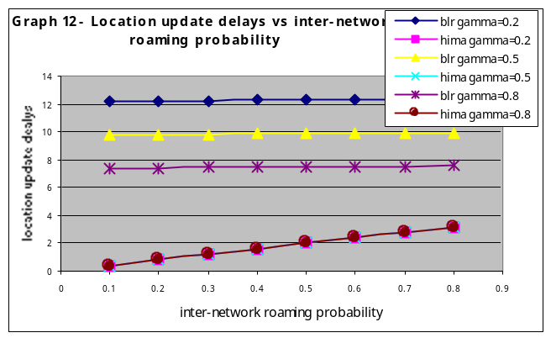
Graph 12 is the plot of the average delays incurred in the location update process versus the inter-network roaming probability. The BLR scheme shows very little variation in the delay with increasing roaming probability, this is because the delays due to the three components that we considered are nearly the same and there is dependency between p₁, p₂ and p₃, i.e. the probability of occurrence for each component is related. The net effect is that the graph shows very little variation with increasing p₂. If the fourth component (from sub case 4 in Section 5.2) had been included, a distinct increase in the delays could have been observed. The HIMA graph on the other hand is primarily dependant on p₂, hence shows an increase with increasing values of p₂. Variation of gamma does not affect the HIMA location update delays.

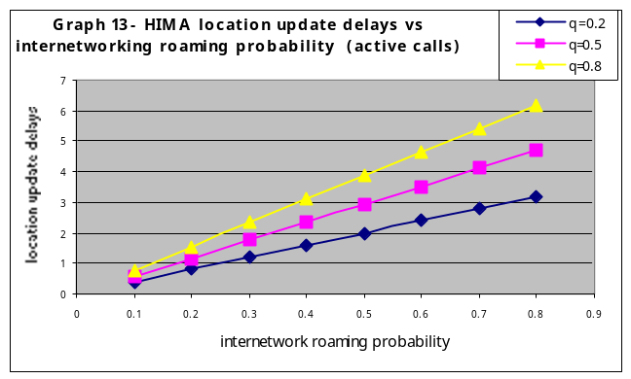

Graph 13 is a plot of the location update delays versus the inter-networking roaming probability for the HIMA scheme for various “active call” probabilities. As the active call probability increases the delays show an increase, because more transmission and processing is involved with more number of calls.

CALL DELIVERY DELAYS
Graph 14 is a plot of the call delivery delays versus internetworking roaming probability for various values of gamma. With a higher probability of the home network being remote (γ is low), the BLR scheme shows an increase in the call delivery delays, whereas no change can be noticed in the HIMA scheme, as the HIMA in this case is acting as a Proxy HLR.
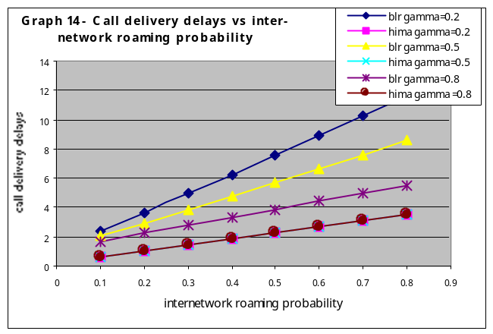
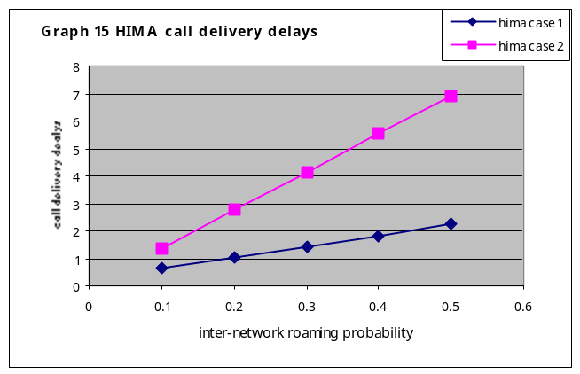
In Graph 15, the slope of the graph for call delivery delay under case 2 of the HIMA, where the AR is involved can be seen to be steeper. If all the networks involved during the call delivery were under one GR, then this slope would be less. As the AR is included in the information flows, the delays increase with increase in roaming probability of the called MT. This is because the called MT has to be first located and then call setup initiated.
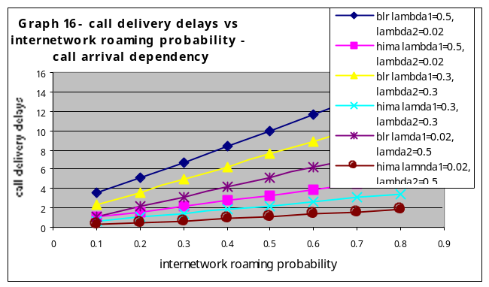
Graph 16 shows a set of plots for the variation of the call delivery delay as the arrival rate from WN2 and WN3 are varied. When the arrival rate from WN2 is high, a higher delay can be noticed as there are two contributing components in this case. The explanation for this occurrence will follow arguments similar to that provided for Graph 9 in Section 6.5.3.

Conclusions
The work proposes a global mobility management framework, which is like an overlay network for mobility management and can facilitate seamless roaming and handoff for mobile users with active call or data connection across different wireless networks. The primary goal being to optimize across call set up delays, signaling traffic, database processing, handoff facilitation for seamless roaming, QoS mapping and negotiations (as the user moves across different wireless networks) and avoid centralized database dependency with its associated single-point bottleneck and failures. We have presented such a framework and analyzed its performance in terms of costs and delays incurred during location registration and call delivery. The specifications and analysis are restricted to a 2-network and a 3-network scenario. Where possible comparison has been provided with some published work. The analysis shows that the primary goals mentioned early with respect to call set up delays, signaling traffic, database processing, handoff facilitation for seamless roaming, and avoidance of centralized database dependency with its associated single-point bottleneck and failures were achieved. The novelty of the work lies in the proposed architecture, which harnesses the advantages of hierarchical control, which would be the best to accommodate for widely varying mobility and call arrival patterns of a mobile user. At the same time mobility management functions are distributed across the wireless and core networks, to minimize the loads on the control nodes. This also provides a better inter-working with the existing mobility protocols in these networks (the inter-working issues are not addressed in this work).

Appendix A: Mechanism to determine a suitable HIMA
The HIMA functions have to be installed in the routers and administered by the ‘network and service’ providers. The HIMA functions can be installed only in routers spanning networks, which have an agreement. The administrators will have to program the HIMA footprint into the HIMA router. A HIMA advertises its presence to the networks in its footprint and the gateway routers of the networks have knowledge of the HIMAs. A Mobile Node which roams across a number of networks, keeps track of its roaming by registering the IP addresses of the networks that it roams in a local database. It can also store the IP addresses of the networks from which it receives a large number of calls. This mobility and call arrival profile is required to be maintained by the mobile node for the mechanism to work. The mobile node then queries the gateway for a suitable HIMA by providing the IP addresses of networks that it roamed into and from which it received a number of calls. The gateway will provide the most suited HIMA based on the IP addresses provided by the Mobile Node. On receiving the information, the Mobile Node will register with this HIMA as the primary HIMA. The information in the HIMA is cached and is discarded if the mobile node does not access the HIMA within a defined time interval. The mobile node keeps track of its mobility profile and can detect changes by noticing any new IP addresses, or IP addresses that it does not use any more. Once it has detected this, it then requests its gateway to refresh its HIMA information. The study on this is not yet complete and is in proposal stages.

References
  - ETSI TS 129 120 V3.0.0, “Universal Mobile Telecommunications Systems (UMTS); Mobile Applications Part specification for a Gateway Location Register (GLR); stage 3”, 3GPP/ETSI 2000, 2000-2003.
  - Wenye Wang, Ian F. Akyildiz, “A New Signalling Protocol for Intersystem Roaming in Next Generation Wireless Systems”, IEEE Journal on Selected areas in communications, Vol 19, No. 10, Oct 2001 pg 2040 -2052
  - Anthony S. Acampora, Mahmoud Naghshineh, “ An Architecture and Methodology for Mobile executed handoff in cellular ATM networks”, IEEE Journal on Selected areas in Communications, Vol., 12, No. 8, October 1994. pg 1365-1375.
  - Nirmala Shenoy, Arek Dadej, John Asenstorfer, Paul Alexander, “Mobility Prediction for Optimal Handover and Connection Management in Mobile Multimedia”, Proceedings of the Third Asia Pacific Conference in Communication '97 Conference, Sydney 7-10 December, pg1236-1240
  - J.S.M Ho and I.F. Akyildiz, “Dynamic Hierarchical Database Architecture for Location Management in PCS Networks”, IEEE/ACM Transaction on Networking, vol 14, no. 5, Oct 2000, pp 646-660.
  - I.F. Akyildiz and Wenye Wang, “A Dynamic Location Management Scheme for Next Generation Multi-tier PCS systems”, IEEE Transaction on Wireless Communications, Vol. 1, No.1, January 2002, pp 178-189.
  - J.Z. Wang, “A Fully Distributed Location Registration Strategy for Universal Personal Communication Systems”, IEEE Journal of Selected Areas in Communications, Vol 11, No. 6, Aug 1993, pp 850-60.
  - Gregory P. Pollini, “Trends in Handover”, IEEE Communications Magazine, March 1996, Vol 34, Issue 3, pp 82-90.
  - I.F. Akyildiz, J. McNair, J. S. M. HO et al, “Mobility Management in Next Generation Wireless Systems” Proceedings of the IEEE, Vol 87, NO 8, August 1999, pp 1347-1384
  - Hesham Soliman, Claude Castullccia, Karim El- Malki, Ludovic Bellia, Internet Draft on HIMIPv6 Oct 2002. http://www.ietf.org/internet-drafts/draft-ietf-mobileip-hmipv6-07.txt
  - Nirmala Shenoy, “Global Roaming in Next Generation Wireless Networks”, Proceedings of the CITC3 Rochester, New York Sept 19-21 2002
  - Kuo Hsing Chaing, Nirmala Shenoy, “Swap Technique for Location Management in Mobile Networks” Proceedings of the IEEE ICC 2002, 28th May – 2nd June, New York.
  - V. Garg and J. E. Wilkes, “Internetworking and interoperability issues for North American PCS”, IEEE Communications magazine vol. 39, pp 94-99, March 1996.


Nirmala Shenoy is Associate Professor at the Information Technology department at RIT. She has several years of teaching and research experience while working in Germany, Singapore and Australia before she moved to USA. She is an avid researcher in the wireless networks area and has technically led several wireless network projects to success. She holds a Ph.D. in computer science from the University of Bremen, Germany, Masters in Applied Electronics and Bachelors in Electronics and Telecommunications Engineering both from Madras University in India. Professor Shenoy is interested in research in the area mobility management and modeling for wireless networks, Quality of service in wireless networks and the Internet.

This work is currently sponsored by Cisco URP grant
This is possible only if the multimode handsets are able to perform switching across the two technologies.
The equations carry the section number

