A Combined Scheduling Scheme for Absolute and Relative Differentiated Services

Nirmala Shenoy*, Sunthiti Patchararungruang**
*Department of Information Technology, Rochester Institute of Technology, Rochester, NY 14623
**Mechatronics Research Group, Department of Mechanical and Manufacturing Eng., University of Melbourne, Australia

INTRODUCTION
As the Internet becomes an important infrastructure of global communication, best-effort services alone cannot meet diverse application expectations. Some applications like the world-wide-web and file transfers prefer low data-loss but can tolerate some time delays. Multimedia real-time applications require low delays but can recover from a certain amount of data loss. Applications like tele-medicine and robot control system in critical mission demand accurate data delivery from source to the destination within a predefined deadline.
DiffServ was proposed to support differentiated services for an aggregation of traffic from different sources called ‘traffic class’[1]. Currently, there are two approaches proposed to realize the DiffServ, Absolute DiffServ [3][4][5][12] and Relative DiffServ [2][6][7]. Absolute DiffServ supports services with absolute profiles (e.g. a certain amount of bandwidth) but without per-flow parameter maintenance in the network core. Absolute DiffServ is complex to implement [12] but would be suitable for time critical applications. Relative DiffServ seeks to provide per-hop relative services to the traffic classes it supports. It cannot guarantee the amount of network resources provided to each class but tries to locally ensure that the QoS of higher priority classes will be better than the lower ones and is suitable to most other classes of traffic. Relative DiffServ is easier to implement than the Absolute DiffServ.
The Internet is expected to support both, applications with hard guarantees and applications, which can take QoS variations. Therefore, the implementation of pure Absolute or Relative DiffServ is inadequate. However providing separate scheduling schemes to support Absolute and Relative Diffserv would impose heavy processing overheads at the routers and unused resources booked for Absolute services may not be easily available for Relative Diffserv services. The proposed work addresses these issues. Highlights of the proposed work are given next.

HIGHLIGHTS OF THE PROPOSED WORK
- One scheduing scheme to schedule one Absolute and several Relative diffserv classes. The algorithm and scheduling scheme to support the Absolute class is the same as that used for the Relative diffserv classes and requires no complex computations. We call the Absolute class as the “premium”class.
- Resource wastage due to reservation made for Absolute class is avoided, without special bandwidth re-allocation mechanisms
- The “Service Differentiation Ratio” used in the Relative Diffserv services is changed dynamically depending on the load in the network.
- In “dynamic service differentiation”, load from a lower priority class will have minimal effect on a higher priority class but more effect on a lower priority class. It will not affect the premium class, because of the “absolute” guarantees.
- The two prime features of this work, fixing the Absolute Qos paramter and varying the “Service Differentiation Ratios” depending on the overload in the metwork are achieved using a distribution. We demonstrate the use of two such distributions.
- The advantage of the scheduling scheme is, the relative “dynamic service differentiation ratio” which can be decided automatically by the distribution.
- The scheme can be used in the interior routers to provides the same absolute guarantees irrespective of the bursts of traffic from the edge routers. i.e the scheme is not affected by traffic aggregation at the interior router.

TRAFFIC CLASSIFICATION
For our study, we focus on four traffic classes, one Absolute class and three Relative classes. The first class is the “premium class” and requires strict QoS guarantees. Traffic from any of the Relative Diffserv classes, should not affect the premium class performance. The second traffic class is a high priority Relative Diffserv class. Heavy load in the lower classes will not affect this class significantly as we change the “service differentiation ratio” based on the load in the network. The third traffic class is given some QoS assurances and will suffer greater QoS loss under heavy traffic conditions. The fourth traffic category does not get any QoS guarantees and will be used by background traffic. The four classes of categorization that we have provided are in-line with the service categorization in the UMTS (Universal Mobile Telecommunications Systems) networks namely the conversational, streaming, interactive and background [11]. However in this study we provide more strict guarantees to the premium class than would be required by the UMTS conversational class as we are targeting time and data critical applications like telemedicine. Nevertheless, the differentiation provided in this scheme can be adjusted to provide mapping of UMTS service if the UMTS network were tethered to IP networks.
In our scheme, all traffic entering the system is classified into n service classes (in this case n = 4). Class 0 is the premium class. The other traffics are fitted into class 1 to n-1 depending on preferred QoS guarantee levels (the priorities of classes go down with increasing class number). Class 1 can be used for time sensitive applications like real-time applications and TCP traffic, which can accept some information loss. Class 2 can be used for most other data traffic, and class 3 can be used by filler or background traffic. Under heavy traffic influx class 0 will suffer no QoS loss, class 1 will suffer some QoS loss especially if the traffic influx was in this class. To generalize, influx in traffic class ‘n’ will have more effect on the QoS in traffic classes n and higher and will have less effects on traffic classes n-1 and lower.

RELATIVE AND ABSOLUTE SERVICE ALLOCATION
To provision for one Absolute class and several Relative Diffserv classes and introduce “dynamic service differentiation” among the relative Diffserv classes we use a distribution. In this study, we have demonstrated the use of a linear and an exponential distribution as examples to explain the scheme.
Let D₀ be the delay parameter that defines absolute maximum in delay requirements of the Absolute class. Let d₀, d₁, d₂, and d₃ respectively define the service differentiation in terms of delay to be applied to all the classes. Hence based on our previous statement on premium class QoS parameter we have
d₀ ≤ D₀ (1)
Instead of using a fixed service differentiation ratio as done in [7][8], we fit d₀, d₁, d₂, and d₃ into a distribution for example a linear distribution as given by equation 2.
y(x) = mx + c (2)
Fixing class 0 service to the value decided by ‘c’ (thereby providing it with strict QoS guarantees) and by changing the slope of the distribution (see figure 1) we can change the relative service allotted to the other classes (i.e. vary the service ratios). In equation 2, y(x) is the service to be provided to a class x and m, the slope of the line decides the service differentiation ratio.
Figure 1 shows the plot of equation 2 for the different classes given by x =0,1, 2 and 3. We define a value m_{min}, where m_{min}=m₀ (the use of this is explained later). Then the equation of the line for m_{min} will be given by
y(x) = m₀x+c (3)
Equation 3 will be used under moderate load conditions when the overall packet incoming rate is less than or equal to the overall outgoing rate. From figure 1 the service differentiation will be given by
d0: d1:d2:d3 = c: s1: s2: s3 (4)
Bold points are placed on the lines and dotted lines from these points are drawn to the x axis identifying the class number i.e. 0, 1, 2 and 3; and to the y axis identifying the relative values based, on which the service ratio will be defined. Under heavy loads, when the overall arrival rate is greater than packet outgoing rate the slope of the line is changed to m>m0. In this case, from figure 1 the service differentiation will be given by
d0: d1:d2:d3 = c: s11: s22: s33 (5)
Under lightly loaded conditions, we maintain m at m_{min} i.e. m_{o} but let the line move down as seen in figure 1 (i.e. reduce c below D₀). This is to satisfy the criteria that high priority classes will be served better than low priority classes. However, an under-loaded network is not a critical case for study.
Notice that in the family of curves suggested, class 0 service is fixed by ‘c’, while m, the slope is adjusted to take care of the increase in the incoming traffic. Bursts in incoming traffic will have less effect for the high priority classes and more effect on the low priority classes which can be clearly seen in the curve for m> m₀. For comparison, we have drawn a similar set of curves, (bold dashed ones) which are used by current schemes. In the current schemes when there is burst traffic in one class, all classes can feel its affect as can be noticed by the upward shift in the dashed curve.
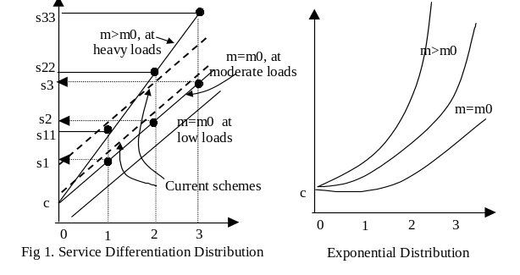
The service differentiation parameters may be linearly distributed as discussed so far, or may have other relationships. We show one more such relationship or distribution, which will be very useful for service differentiation, the exponential distribution, which is shown next to the linear distribution in figure 1. The shift of the exponential curve to heavy traffic influx is indicated in the figure by curves marked m > m₀ (the equation used is y(x) = ce^{mx}). Unlike the linear distribution, the exponential distribution can be used to provide a more biased service to the high priority classes as compared to the low priority classes.
We next define a mechanism to adjust m whereby m can be increased or decreased (but not below m₀) in response to the changes in d₀ the delay measured for class 0. This is given by equation 6 and 7. t and t+1 are consecutive time instants of calculations.
Δm = (d₀ – D₀) / D₀ (6)
m_{temp} = m(t) + Δm (7.1)
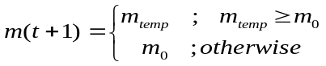 (7.2)

SERVICE DIFFERENTIATION AND SCHEDULING
For the scheme described in section 4, we intend to obtain relative service differentiation ratio for all classes. We use these priority calculations to control scheduling from each class. It can be noticed that the “Service Differentiation Ratio” is dynamic. We apply this dynamic “service differentiation ratio” mechanism to both, a Waiting-Time Priority (WTP) (as implemented in [7]) and a Weighted Fair Queue (WFQ) (as implemented in [8]) scheduling algorithms. This is explained in the next sections.

WTP with support for one Absolute Class
From the mechanism of WTP described in [7], the priority of a packet increases proportionally with its waiting time in a priority queue. Let w(t) be waiting time of a packet at time t. The priority p of a packet in service queue i at time t can be specified as in equation 8.
p_{i}(t) = w_{i}(t) / s_{i} (8)
The variable s_{i} is the Differentiation Parameter of queue i. It is same for all packets within queue i. In our scheme, it is set to y(i) from equation 2 and varies based on the traffic in the network.

WFQ with support for one Absolute Class
In [8], which is a variation of the simple WFQ scheme, the researchers have introduced mechanisms to predicatively change queue service priority based upon the backlog and the arrival rate at the queue over a certain interval. We use the equation provided by these researchers and this is reproduced below for easy reference as equation 9.
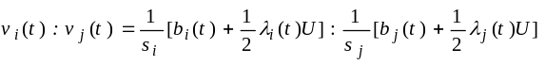 (9)
In equation 9, at time t, v_{i}(t) represents service rate ratio of class i, s_{i} is “service differentiation” parameter, b_{i}(t) is current backlog size, λ_{i}(t) represents current queue input rate, and U is tuning time interval. We have used the values of y(i) instead s_{i}.

SIMULATION CONFIGURATION
In order to study the proposed scheme, simulations were conducted using the topology shown in Figure 2. The scheme is also implemented in the interior router. We have used the Opnet Network Simulation Tool to help model and conduct studies of the proposed topology. The topology consists of three DiffServ routers two of which are edge routers and an interior router that implements per-hop behaviour forwarding. Studies limiting the buffer size and taking into consideration the drop probabilities for the Relative Diffserv services have not been included due to space limitations. However, it is assumed that edge routers will provide policing and dropping of packets beyond the contracted values.
Five different traffic sources are shown, four of them model traffic generated by each of the service classes we identified, while the last one is a burst source and can be configured to introduce burst traffic in any one of the classes.
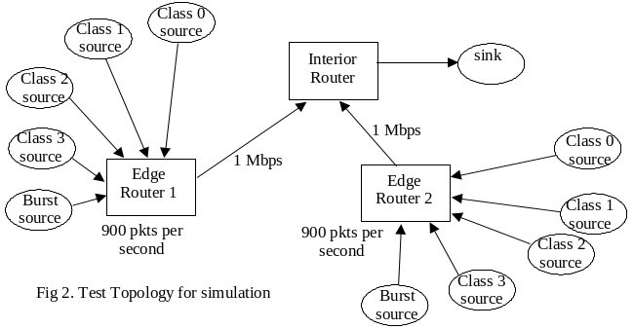 We have configured the traffic sources to run just under moderate load. When the burst source is activated, the routers would be overloaded. For this study, the burst source was activated once for duration from 15-60 seconds. The interior router service rate is also configured to be on moderate load normally and to be overloaded when both the burst sources are active. Each source generates an average of 200 packets per second (exponentially distributed), with each packet averaging a size of 1024 bytes. The burst source generates an average of 350 packets per second over its specified duration. The edge routers are configured for a service rate of 900 packets per second and the interior routers at 1750 packets per second.
The modified WTP and WFQ, which implement our scheme is called the DDWFQ (Dynamic Differentiation WFQ) and DDWTP schemes. For the DDWFQ scheme we specify the “premium class acceptable backlog”, which has to be calculated based on the routers service capacity and the delays acceptable to this class. For the edge router this backlog is set at 5 packets, to limit the delay in the premium class to 30 milliseconds. For the interior router the backlog is set at 12 packets (calculations to estimate these are not provided here). This decides the value of ‘c’ in equation 2. For the DDWTP, the premium class waiting time or delay was set to 30 milliseconds at all routers. To start with, we also used a service differentiation ratio of 0.1:1:10:100.

SIMULATION RESULTS
The different cases we present here are Case A – WFQ as proposed in [8], Case B -DDWFQ, Case C- WTP as proposed in [7] and Case D- DDWTP. In each of these cases, we compare the performance and highlight the major effects of the proposed dynamic differentiation scheme with support for one Absolute class. For each of these cases we also introduce the results we obtained for the “interior router” using the same scheduling scheme. In the graphs, subqueue[0] is the queue for class 0, subqueue[1] is the queue for class 1 and so on.
Case A –WFQ - Performance Graphs
We will first highlight the performance of the WFQ scheme as proposed in [8]. In the next section, when we present the graphs from the proposed scheme we will also provide the comparisons.
In graph 1.a, the effect of bursts in class 0 (edge router 1) and class 1(edge router 2) are shown at the interior router. The premium class suffers a maximum delay of 45 milliseconds. The effect of the fixed “Service Differentiation Ratio” supported by this scheme can be seen from the delays experienced by each class. The peaks indicate the time when the bursts occurred. Graph 1b is the delay experienced by the different classes at an edge router as a result of overload in class 0.
Class 0 experience a maximum delay of 50 milliseconds. The other classes experience a relative delay based on the fixed “service differentiation ratio”. In Fig 1c and 1d we have overloaded classes 1 and 3 respectively (with the same amount of burst traffic) and in all cases the highest priority class can be seen to be effected by traffic influx in the lowest priority class i.e. a burst in the filler traffic class affects the traffic in the highest priority class. This would result in “delayed” packets or stale packets that would have to be dropped by the highest priority class.
In all case the overload effects on class 2 are not only due to space consideration, but their effect can be inferred from the overload effects on classes 1 and 3.
Case B: DDWFQ – Performance Graphs
Graphs 2a to 2d are performance graphs collected for the DDWFQ scheme. The traffic setup is the same as used for the WFQ scheme. Burst traffic was introduced in class 0 and class 1. For the “interior router” as shown by graph 2a, we notice that the maximum delay suffered by the premium class is below 30 milliseconds as desired. Graph 2b shows the effect of overload introduced in class 0 at the edge router. The delay for the premium class never exceeds the 30 milliseconds limit. However, when the overload is in the other classes, Class 0 traffic still goes with a maximum delay of 30 milliseconds, i.e it still takes a share of the overload while the other classes share the load, with slightly increased differentiation ratio. Class 0 could have been handled as priroity queue in which case all traffic entering class 0 will be handled first and it would not have shared in the traffic overload. By sharing the traffic overload there is more fairness among the treatment of all classes, and at the same time not jeopardizing the quality of the premium class. Graph 2c and 2d show the effect of overload on class 1and 3. As can be seen form these graphs, the premium class takes it share of overload without affecting its QoS.
Case C: WTP – Performance Graphs
Graphs 3a to 3d are the performance graphs for the WTP scheme[7]. Graph 3a gives the delay performance at an interior router implementing WTP with the specified service ratio. The traffic burst was introduced in class 0 at edge router 1 and class 1 in edge router 2, the effects of which can be seen in this graph. The high priority class suffers a delay of nearly 50 millisecond and the service is allocated as per the service ratio to all other classes.
However, it should be noted that neither WTP nor WFQ were developed to provide hard QoS guarantees and their behaviour is as predicted by the researchers in [7] and [8] respectively. Graph 3b is a plot of the effects of traffic burst in class 0 at edge router 1. The delay suffered by the premium class is 60 milliseconds. Graphs 3c and 3d show the effects of traffic overload in classes 1 and 3. The WTP scheme is more effective than the WFQ though complex to implement and one can notice that, lower the priority of the class introducing the overload, less is its effect on the highest priority class. The highest priority class delays go down from 60 milliseconds to 50 milliseconds and 30 milliseconds when the overloading class goes from class 0, 1 and 3 respectively. However the overload effects in classes 0, 1, and 3 are felt at the premium class.
Case D: DDWTP – Performance Graphs
Graphs 4a to 4d show the performance of the DDWTP. Graph 4a shows the performance of the Interior Router to overload bursts in traffic class 0 (edge router 1) and traffic class 1 (edge router 2). As decided by the distribution, the maximum delay for this class is limited to 30 milliseconds even at the Interior Router. Fig 4b shows the overload effects in class 0 at edge router 1. The premium class is limited to the ‘set’ maximum delay and the other classes take a relative share of the overload. The same effect can be felt when there is overload in classes 1 and 3. The premium class takes its share of the overload without affecting its QoS guarantees.

CONCLUSIONS
In this work, we have presented a single scheduling scheme that can be used to schedule one Absolute class and several Relative Diffserv classes. By the use of the single scheme, the complexity of using two separate scheduling schemes one for Absolute Class and the other for Relative class is avoided. Also, the scheme is an enhancement to the Relative Diffserv scheme, thereby avoiding complex schemes for the support of an Absolute class. Moreover, the scheme maintains the Qos for the Absolute class strictly while sharing in the overload in the network along with the other classes. The lower priority classes take more of the overload than the higher priority class. All this is achieved through the use of a distribution, which can be used with any scheduling scheme and adds a few more lines of code. The scheme was implemented in a WTP and a WFQ scheme and performance comparison provided with the corresponding WTP and WFQ scheme. The results show the enhancements introduced by implementing this scheme.
REFERENCES
[1] S. Blake, et al., an Architecture for Differentiated Services, RFC 2475, Dec 1998.
[2] J. Heinanen, et al., Assured Forwarding PHB Group, RFC 2597, Jun 1999.
[3] V. Jacobson, et al., An Expedited Forwarding PHB, RFC 2598, Jun 1999.
[4] R. Sivakumar, T. Kim, N. Venkitaraman, and V. Bharghavan, Achieving Per-Flow Weighted Rate Fairness in a Core Stateless Network, Proceedings of IEEE ICDCS 2000, 2000.
[5] I. Stoica and H. Zhang, Providing Guaranteed Services without Per Flow Management, Proceedings of ACM SIGCOMM’99, Aug 1999.
[6] A.M. Odlyzko, Paris Metro Pricing: The Minimalist Differentiated Services Solution, Proceedings of IEEE/IFIP International Workshop on Quality of Service, Jun 1999.
[7] C. Dovrolis, D. Stiliadis, and P. Ramanathan, Proportional Differentiated Services: Delay Differentiation and Packet Scheduling, Proceeding of ACM SIGCOMM’99, Aug 1999
[8] C. Li, S. Tsao, M.C. Chen, Y. Sun, and Y. Huang, Proportional Delay Differentiation Service Based on Weighted Fair Queuing, Proceeding of IEEE ICCCN 2000, 2000
[9] Network Simulator (ns) version 2, “http://www.isi.edu/nsnam/ns/”
[10] A. Demers, S. Keshav, and S. Shenker, Analysis and Simulation of a Fair Queuing Algorithm, Proceeding of ACM SIGCOMM’89, 1989.
[11] Soliris I. Maniatis, Eugenia G. Nikolouzou and Lakovos S. Veniers, “QoS Issues in the Converged 3G Wireless and Wired Networks”, IEEE Communications Magazine, August 2002, pg 44-53.
[12] B Davie et al. An Expedited Forwarding PHB, RFC 3246, March 2002.
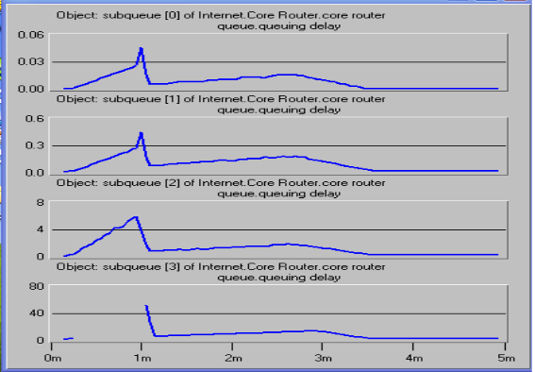
Fig. 1a. WFQ Interior Router – overloaded classes 0 & 1
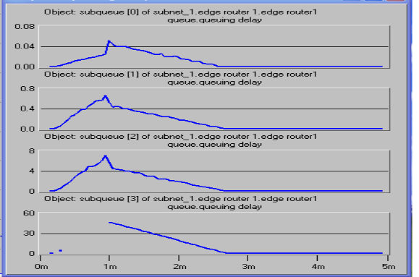
Fig 1b. WFQ Edge Router – overloaded class 0
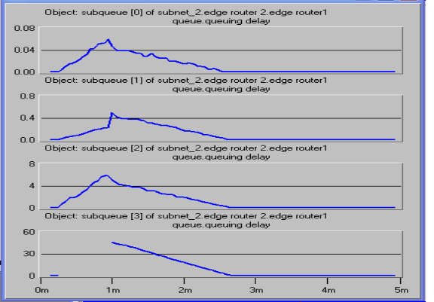
Fig 1c. WFQ Edge Router – overloaded class 1
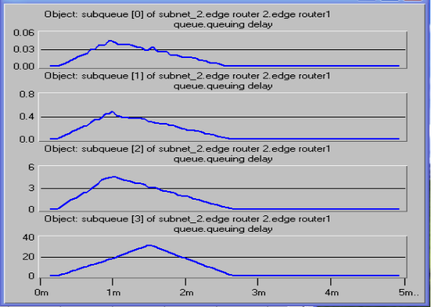
Fig 1d. WFQ Edge Router – overloaded class 3
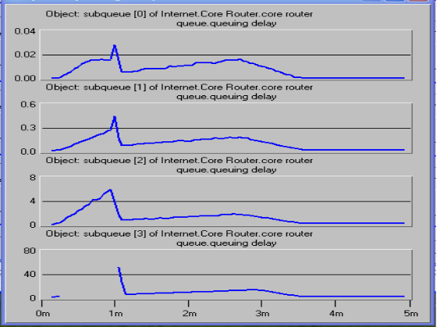
Fig 2a. DDWFQ Int router -overloaded classes 0 & 1
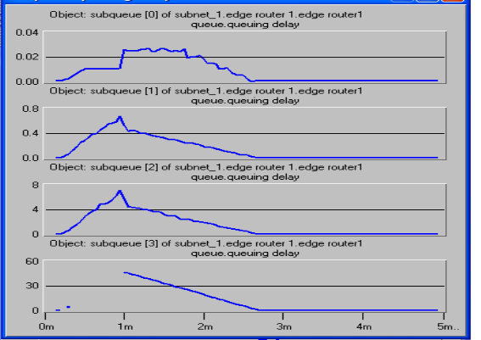
Fig 2b. DDWFQ Edge router -overloaded class 0

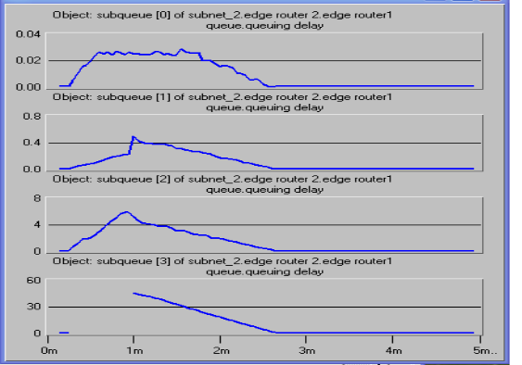
Fig 2c. DDWFQ Edge router -overloaded class 1
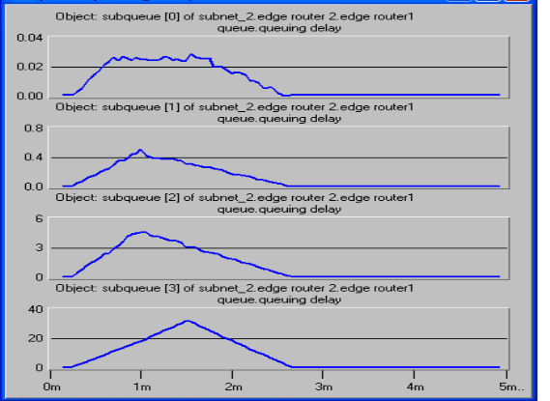
Fig 2d. DDWFQ Edge router -overloaded class 3
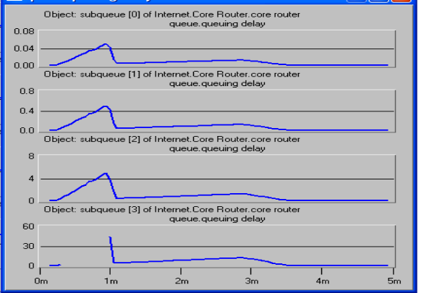
Fig 3a. WTP Interior router -overloaded classes 0 & 1
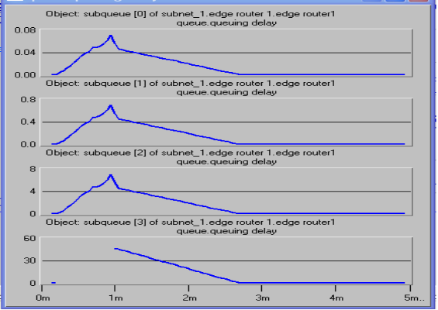
Fig 3b. WTP Edge router -overloaded class 0
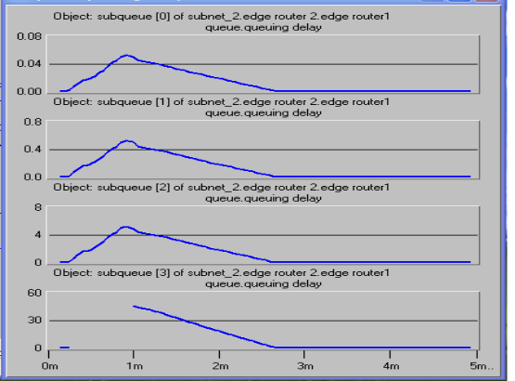
Fig 3c. WTP Edge router -overloaded class 1
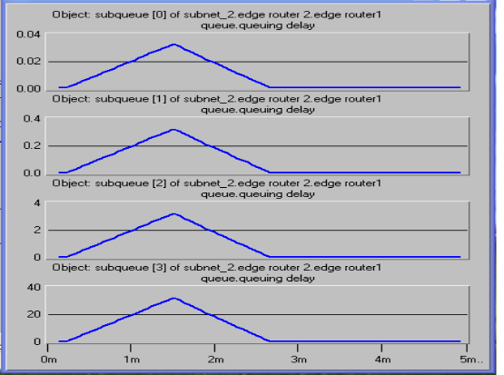
Fig 3d. WTP Edge router -overloaded class 3
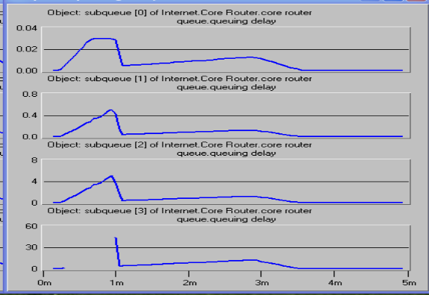
Fig 4a. DDWTP Int router -overloaded classes 0 & 1
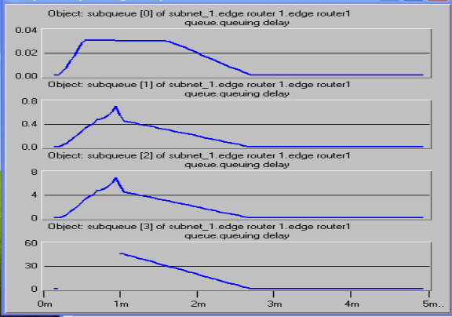
Fig 4b. DDWTP Edge router -overloaded class 0
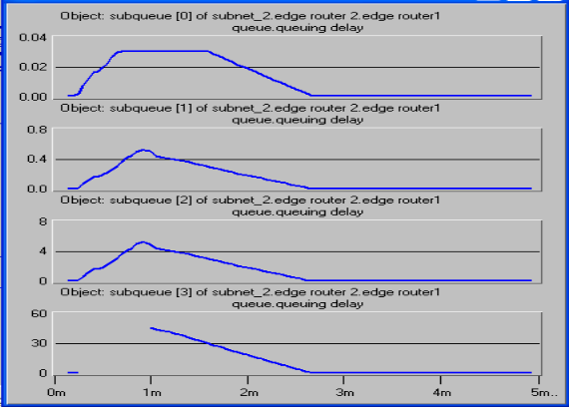
Fig 4c. DDWTP Edge router -overloaded class 1
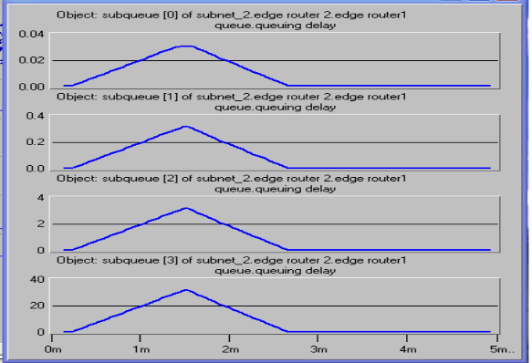
Fig 4d. DDWTP Edge router -overloaded class 3

